Cubesat EM Material Discharge Eval

Joshua Feldman

Michael Kim

Ian Poynter

Alejandro Torres

**Concept of Operations**

REVISION – 1

3 December 2023

Concept of Operations

for

Cubesat EM Material Discharge Eval

Team 44

Approved by:

_____________________________

Project Leader Date

_____________________________

Prof. Kalafatis Date

_____________________________

T/A Date

**Change Record**

| **Rev.** | **Date** | **Originator** | **Approvals** | **Description** |
| --- | --- | --- | --- | --- |
| **-** | [9/14/2023] | [Ian Poynter] |  | Draft Release |
| 1 | [12/3/2023] | [Ian Poynter] |  | End of Semester Revision |

**Table of Contents**

**Table of Contents** **3**

**1.** **Executive Summary 4**

**2.** **Introduction 5**

2.1. Background 5

2.2. Overview 6

2.3. Referenced Documents and Standards 6

**3.** **Operating Concept 7**

3.1. Scope 7

3.2. Operational Description and Constraints 7

3.3. System Description 7

3.4. Modes of Operations 8

3.5. Users 8

3.6. Support 8

**4.** **Scenario(s) 9**

4.1. Orbiting Satellites 9

4.2. Deep Space Propulsion 9

**5.** **Analysis 10**

5.1. Summary of Proposed Improvements 10

5.2. Disadvantages and Limitations 10

5.3. Alternatives 10

5.4. Impact 10

# **Executive Summary**

As humanity continues to prioritize space travel, new technologies continue to be developed that help sustainable interplanetary travel become a reality. Ion thrusters are one such technology, creating thrust by accelerating ions with a high voltage. The ion thruster was first proposed in 1911 and first built successfully in 1959 at NASA, but current ion thrusters have low acceleration and require expensive Xenon as fuel. The Relativistic Ion Thrust Drive, or RIOT Drive, proposed by Orbital Arc plans to change that. The RIOT Drive will use a gentler ionization method than current Hall-Effect or gridded thrusters so cheaper and heavier fuel can be used, providing a much stronger propulsion and higher efficiency. For this project, we will design the chassis and essential systems of the first working prototype of the RIOT Drive, to produce a proof of concept that is functional enough to entice investors to sponsor a larger-scale project.

# **Introduction**

The Relativistic Ion Thrust Drive, or RIOT Drive, is an ion thruster that will ionize the fuel more gently than contemporary thrusters. This will allow the RIOT drive to use heavier fuel and accelerate the ions at a higher velocity providing about four times more efficiency than current ion thrusters. We will design the geometry, chassis, and software for a prototype of the RIOT Drive for Orbital Arc to improve in the future. Deliverables will include a CubeSat Standard compliant chassis, a functional power supply circuitry and microcontroller system for testing, and data collection coming from electrostatic potential testing on different accelerator plate shapes and insulating materials.

## ***Background***

Ion thrusters are used for deep space travel in a variety of applications: from adjusting satellite orbits to propelling spacecraft throughout the solar system [1]. The most common types of ion thrusters are electrostatic or gridded, and electromagnetic or Hall-effect thrusters. Gridded Ion thrusters are more commonly used [2], and they operate by adding electrons to fuel to produce ions [1] and then accelerating the ions at a high velocity through electrically charged grids at the back of the thruster to produce thrust [2]. Most ion thrusters ionize by bombarding the atoms with high-energy electrons producing a positively charged ion [1]. The most common propellant used in ion thrusters is Xenon because it is easily ionized, it has high atomic mass, and it is a noble gas. These properties allow the ion thruster to have higher efficiency than less easily ionizable atoms, generate stronger thrust than other lighter ions, and remain stable during the ionization process. [1] [2].

The primary parts of an ion propulsion system include the ion thruster, the power processing unit, the propellant management system, and the digital control interface unit [1]. To power an ion thruster, electricity is provided by a spacecraft’s solar panels, [2] then the power processing unit, or PPU, converts the electricity into the voltages needed to accelerate the ions [1].

Orbital Arc was founded in February 2023 from the idea of the Relativistic Ion Thrust Drive or RIOT Drive. The RIOT drive is based on a linear particle accelerator and ionization without bombardment. With a linear particle accelerator, the exhaust velocity will reach several percent of the speed of light and exhibit relativistic mass expansion. These factors will increase the efficiency of the RIOT Drive over contemporary ion thrusters by about 4 times [3]. The second component of the RIOT Drive is the method of ionization. The current bombardment method of ionization will break molecular bonds, so an atomic fuel like Xenon must be used. The ionization of the RIOT Drive will use field effect ionization to generate ions cold and accelerate them without containment. This eliminates the problems of bombardment and allows a heavier fuel such as Sulfur Hexafluoride to be used [3].

## ***Overview***

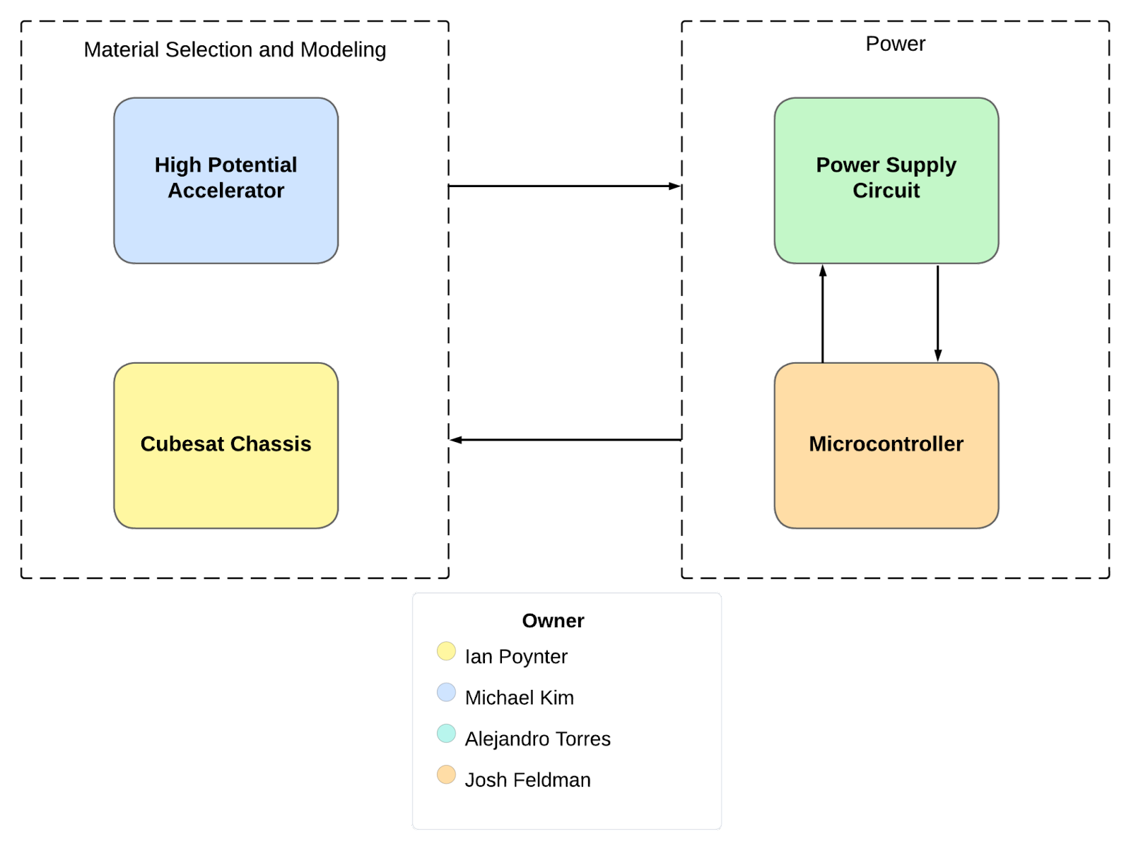

The RIOT Drive is a type of electrostatic ion thruster designed for deep space travel and has the design capabilities that reduce its reliance on delta-v compared to current ion thrusters. The primary limiting factor on the application of the thrust will be the power system that the ion thruster employs. The system will be tested with three different materials and three different geometries, totaling 9 different prototypes to be modeled. The system will also implement a circuit design that will fit within one unit of a CubeSat and will adhere to the required design specifications to power the thruster.

## ***Referenced Documents and Standards***

1. Dunbar, Brian. “Ion Propulsion.” *NASA*, NASA, 18 Aug. 2015, [www.nasa.gov/centers/glenn/about/fs21grc.html](http://www.nasa.gov/centers/glenn/about/fs21grc.html).
2. Wessels, Wessel. “Ion Thrusters - What They Are and How They Work.” *Headed For Space*, 30 Jan. 2023, headedforspace.com/ion-thrusters-and-ion-propulsion/
3. *Orbital Arc*, 16 Aug. 2023, orbitalarc.com/.

# **Operating Concept**

## ***Scope***

The RIOT drive prototype will fit on a CubeSat and propel it into outer space using Sulfur Hexafluoride as fuel. The Sulfur Hexafluoride will be ionized by nanotechnology designed by Orbital Arc and accelerated by a high-voltage plate to provide thrust. The fuel will then be neutralized by electrons to prevent a positive charge buildup behind the thruster that reduces efficiency. This will make the thruster an efficient method of propulsion for space travel, and can potentially revolutionize deep space propulsion in the future. For our prototype, we will establish a power supply with the ability to reliably deliver the necessary power to all required components on board while operating in a space environment. Additionally, experimental data will be collected on different accelerator plate geometries and materials, as well as different shielding techniques.

## ***Operational Description and Constraints***

This project will be designed to function in the following conditions:

* Conditions of outer space, being a near vacuum environment and near absolute zero temperatures.
* The electronics need to be properly shielded from the normal operating voltage of 10kV and potential surges up to 100kV from the accelerator.
* The fuel supply needs to be precisely regulated over a large range of pressures.
* The solar panels that power the thruster need to receive enough sunlight as the CubeSat moves further from the sun.
* Many of the parts will be supplied by Orbital Arc, and will not be available for the demonstrations.

## ***System Description***

* Accelerator: A gridded accelerator allows ions to accelerate at high speed. It also uses relativistic mass expansion to vastly increase the effective mass of fuel flowing out of the thruster. Responsibilities include material and geometry selection, data collection, and construction of a final plate to integrate with the CubeSat
* Power Network: Responsible for delivering correct voltage and amperage to multiple components, including the high voltage accelerator plates, thermionic cathode, ionizer chips, gas feed control valves, etc. Will need to fit inside one CubeSat unit and be capable of regular function in a space environment.
* CubeSat Chassis and Modeling: Responsible for procurement and construction of the CubeSat prototype, as well as taking responsibility for design parameters around safety and ability to operate in space. Thermal considerations will need to be taken to keep the ambient temperature in the system at a temperature where all components can operate. Calculations will be done to ensure compliance with NASA’s outgassing and radiation standards where possible.
* Microcontroller: Where a fully functional RIOT Drive would utilize the on-board electronics of the spacecraft, our prototype will implement a microcontroller to control the electronics of the system. The microcontroller will be able to activate the pulse charger, thermionic cathode, and ionizer chip as needed. The microcontroller will be located on the same PCB as the power supply.

## ***Modes of Operations***

The RIOT drive will operate in normal propulsion mode and directional mode. Normal propulsion mode will accelerate the ions directly away from the CubeSat to propel it forward. The directional mode will induce a variable voltage on the plates to accelerate the ions at an angle. This can turn the CubeSat for any course corrections that are needed.

## ***Users***

The RIOT Drive prototype will be designed for use by Orbital Arc to provide them with testing data for future designs. The RIOT Drive has the potential to revolutionize space travel in the future and in the future will be an improvement over current ion thrusters in space missions for NASA, ESA, or any space exploration company.

## ***Support***

The users will be provided with support through instruction documents from Orbital Arc and meetings with Orbital Arc and the consumer company to discuss how the RIOT Drive will be used. For our prototype, thorough documentation of the design and operation will be provided through our FSR and ICD documents.

# **Scenario(s)**

## ***Orbiting Satellites***

Ion thrusters play a pivotal role in the operation of orbiting satellites, from maintaining the orbit of China’s Tiangong Space Station to performing maneuvers for the SpaceX Starlink satellites. The efficiency of ion thrusters allows them to maneuver satellites in orbit with small amounts of fuel, allowing the satellites to operate for longer with a limited fuel source. Ion thrusters have great functionality in satellites, from small adjustments to deorbiting, and the RIOT Drive has the potential to accomplish these tasks more efficiently and cheaply.

## ***Deep Space Propulsion***

Ion thrusters are crucial propulsion systems for deep space missions. Although ion thrusters accelerate gradually, they offer unparalleled efficiency and longevity compared to traditional fuel-based propulsion. Ion thrusters have been instrumental in missions like NASA’s Dawn or the ESA’s BepiColombo, which are exploring the asteroid belt and Mercury, respectively. An ion thruster’s low fuel consumption and ability to operate over extended periods make them the best choice for enabling intricate trajectories and exploration beyond the Earth’s orbit. The superior fuel efficiency and cost of the RIOT Drive compared to contemporary ion thrusters will progress advanced deep space exploration.

# **Analysis**

## ***Summary of Proposed Improvements***

Our project will produce the first working prototype for the RIOT Drive, and will include tasks such as:

* Electrostatic accelerator which can accumulate up to 100kV of potential on surface
* Shielding from the electric field to protect internal electronics
* Internal circuit board to supply power to all system components
* Material, geometry, and component selection for all systems
* Capability to withstand physical stresses of space launch

## ***Disadvantages and Limitations***

Potential limitations of the RIOT Drive project include:

* Many unknowns in performance as an emerging technology
* Inability to generate enough thrust to achieve liftoff on its own
* Limited ability to fully test prototypes due to no access to the ionizer chips
* Limitations in testing many components in vacuum conditions
* Many considerations for space readiness can not be tested, only modeled
* Small model may perform differently than full-size product

## ***Alternatives***

As space travel currently exists, there are many alternatives to the RIOT Drive. These include:

* Traditional fuel propulsion
  + Able to achieve liftoff and exit Earth’s gravity independently
  + Already a proven method
  + Significantly less fuel efficient and a much heavier fuel
  + Takes up significantly more aircraft space
* Current Ion Thrusters
  + Generally considered ineffective for spacecraft, except for long-term control or small adjustments
  + Uses a less efficient and much more expensive fuel, Xenon
  + Currently used for station-keeping

## ***Impact***

While ion thrusters are currently not viable for much more than slight adjustments in space, a working RIOT Drive will change that. Very few propulsion systems can compete with the delta-V that the RIOT Drive will provide, and it will become the preferred propulsion method for deep space missions. The significant reduction in fuel costs will make it more feasible to implement on satellites in ways that were too expensive or inefficient before. While this prototype will fit in a CubeSat, future systems will be larger, capable of creating enough thrust to be the main propulsion device of a large rocket or satellite once it reaches space. The RIOT Drive will allow us to send satellites further into space because of its high efficiency and speed, potentially leading to significant discoveries.

CubeSat EM Material Discharge Eval

Joshua Feldman

Michael Kim

Ian Poynter

Alejandro Torres

**Functional System Requirements**

REVISION – 1

28 September 2023

Functional System Requirements

for

CubeSat EM Material Discharge Eval

Prepared by:

_____________________________

Author Date

Approved by:

_____________________________

Project Leader Date

_____________________________

John Lusher, P.E. Date

_____________________________

T/A Date

**Change Record**

| **Rev.** | **Date** | **Originator** | **Approvals** | **Description** |
| --- | --- | --- | --- | --- |
| - | 9/28/2023 | Ian Poynter |  | Draft Release |
| 1 | 12/3/2023 | Ian Poynter |  | End of Semester Revision |

**Table of Contents**

**Table of Contents 3**

**List of Tables 4**

**List of Figures 5**

**1.** **Introduction 6**

1.1. Purpose and Scope 6

1.2. Responsibility and Change Authority 6

**2.** **Applicable and Reference Documents 7**

2.1. Applicable Documents 7

2.2. Reference Documents 7

2.3. Order of Precedence 7

**3.** **Requirements 8**

3.1. System Definition 8

3.2. Characteristics 9

3.2.1. Functional / Performance Requirements 9

3.2.1.1 Accelerator Plate….………………………………………………………………..9

3.2.1.2 Shielding………..….………………………………………………………………..9

3.2.1.3 Microcontroller….….………………………………………………………………..9

3.2.2. Physical Characteristics 9

3.2.3. Electrical Characteristics 10

3.2.4. Environmental Requirements 11

3.2.5. Failure Propagation 12

**4.** **Support Requirements 13**

**Appendix A Acronyms and Abbreviations 14**

**Appendix B Definition of Terms 15**

[**Appendix C Interface Control Documents 16**](https://docs.google.com/document/d/1t3NkrBOtiweF0iw42QotZK7ubwHRQshZ/edit#heading=h.2p2csry)

**List of Tables**

**Table 1: Subsystems and Responsibility**………………………………………………….**6**

**Table 2: Applicable Documents**……………………………………………………………..**7**

**Table 3: Reference Documents**…………………………………………………………...…**7**

**List of Figures**

**Figure 1: Your Project Conceptual Image 1**

[**Figure 2: Block Diagram of System 4**](https://docs.google.com/document/d/1t3NkrBOtiweF0iw42QotZK7ubwHRQshZ/edit#heading=h.44sinio)

# 

# **Introduction**

## ***Purpose and Scope***

The purpose of this project is to design and build the prototype of the RIOT Drive that will have the capability to fit within 1U of a CubeSat with an emphasis on maintaining a low weight to reduce the costs for launch and maximize propulsion while in space. The prototype will be specifically designed to measure the data of different geometries and materials used to see the efficiency of each model. We will also design the power supply within the prototype to deliver power to the components of the RIOT Drive. Figure 1 shows a rough design of a modeled prototype with one of the geometries that is used.

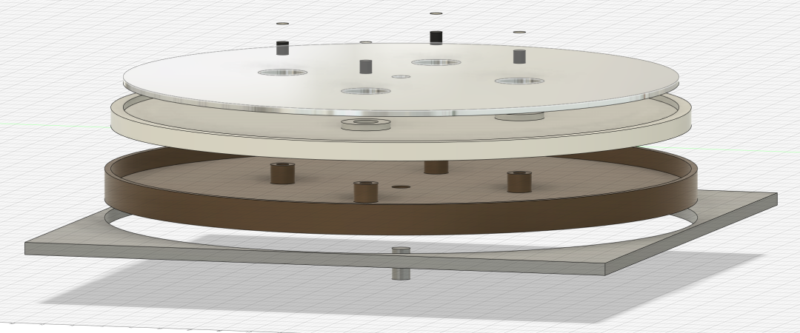

Figure 1: Model of Orbital Arc RIOT Drive

## ***Responsibility and Change Authority***

The team leader, Ian Poyner, is responsible for ensuring all requirements for the system are met. Changes made to each subsystem are to be approved by the team leader and Professor John Lusher. Subsystem responsibility is as follows:

| **Subsystem** | **Responsibility** |
| --- | --- |
| High Potential Accelerator Modeling | Michael Kim |
| CubeSat Chassis Construction | Ian Poynter |
| Power Supply Circuit | Alejandro Torres |
| Microcontroller | Josh Feldman |

Table 1: Subsystems and Responsibility

# **Applicable and Reference Documents**

## ***Applicable Documents***

The following documents, of the exact issue and revision shown, form a part of this specification to the extent specified herein:

| **Document Number** | **Revision/Release Date** | **Document Title** |
| --- | --- | --- |
| 19970027853 | Revision 4 - June 1997 | Outgassing Data for Selecting Spacecraft Materials |
| CP-CDS-R14.1 | Revision 14.1 - February 2022 | CubeSat Design Specifications |

Table 2: Applicable Documents

## ***Reference Documents***

The following documents are reference documents utilized in the development of this specification. These documents do not form a part of this specification and are not controlled by their reference herein.

| **Document Number** | **Revision/Release Date** | **Document Title** |
| --- | --- | --- |
| 20210018053 | July 1, 2021 | Avionics Radiation Hardware Assurance (RHA) Guidelines |
| 19920003068 | September 1991 | NASA Reliability Preferred Practices for Design and Test |
| NPR 7120.10B | June 1, 2022 | Technical Standards for NASA Programs and Projects |

Table 3: Reference Documents

## ***Order of Precedence***

In the event of a conflict between the text of this specification and an applicable document cited herein, the text of this specification takes precedence without any exceptions.

All specifications, standards, exhibits, drawings or other documents that are invoked as “applicable” in this specification are incorporated as cited. All documents that are referred to within an applicable report are considered to be for guidance and information only, except ICDs that have their relevant documents considered to be incorporated as cited.

# **Requirements**

## ***System Definition***

Our project will be making the first functional prototype for the RIOT Drive, proposed by Orbital Arc. Our goal is to design power supply circuitry capable of delivering the necessary power to all components that would be present in a launch-ready system. We will also be collecting experimental data on the electric field produced by the different accelerator plate geometries and materials. Additional responsibilities include designing the microcontroller system to operate components such as the gas feed valve and pulse chargers, the design of the CubeSat chassis, and risk consideration calculations such as thermal, radiation, and outgassing.

Figure 2: Block Diagram of System

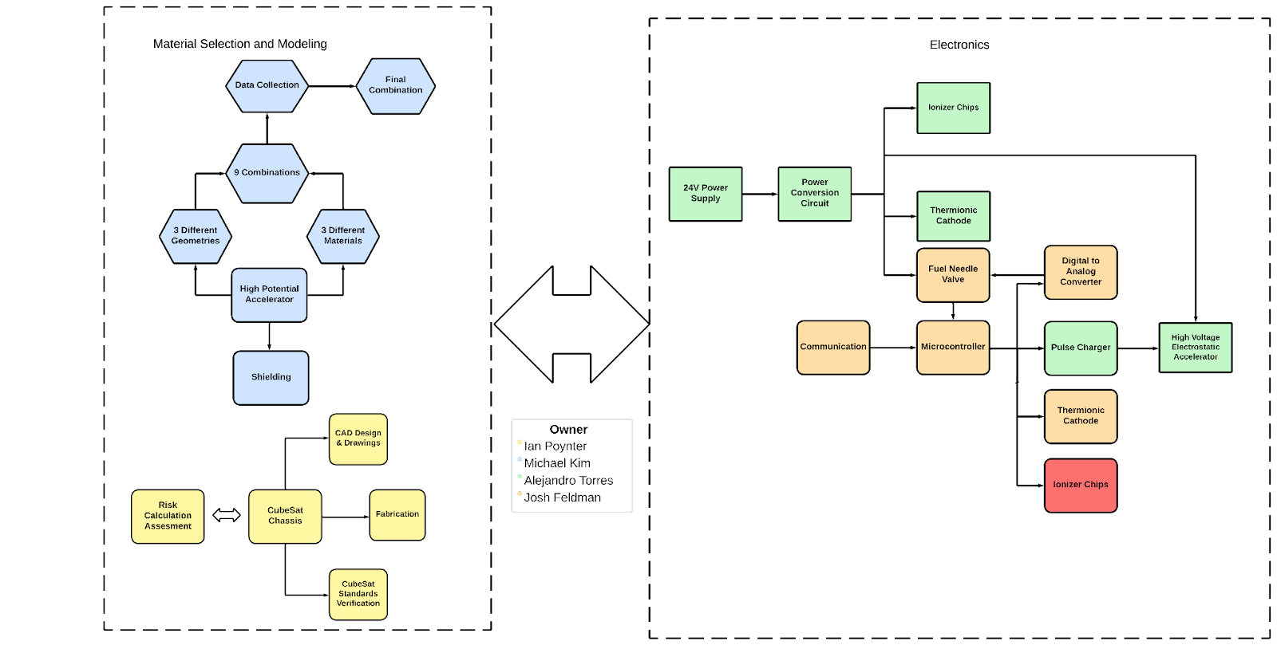

Figure 3: Expanded Block Diagram of Subsystems

The RIOT Drive prototype shall have 2 main components broken down into 2 subsystems each. The high potential accelerator shall include the construction of the plate that holds the high voltage for accelerating the ions, and shielding of the software from the voltage on the plate. This subsystem will interface with the chassis for mounting, the power circuit for charging the plate, and the microcontroller for enabling the plate and determining the amount of charge. The CubeSat chassis shall be constructed of material that can withstand space launch and travel. It will fit inside a CubeSat, and be constructed to mount the accelerator plate and shielding, and the power supply circuit. Ian Poynter will be creating the chassis out of aluminum 7075. The power supply circuit will take a 24VDC input and supply proper power to all components, including the pulse charger for the accelerator plate, the thermionic cathode, the ionizer, the gas feed control, and the microcontroller. The microcontroller will control charging the accelerator plate, the gas feed control, the ionizer, and the thermionic cathode.

## ***Characteristics***

### **Functional / Performance Requirements**

#### **Accelerator Plate**

The RIOT Drive accelerator shall sustain a charge of 40kV $±1\%$ and reach up to 100 kV $±1\%$.

*Rationale: This is the highest voltage our RIOT Drive would ever need, specified by Orbital Arc, so testing the maximum voltage ensures that lower voltages are sustainable.*

#### **Shielding**

The Accelerator shall be shielded from the electronics so the electronics can function without interference. Thermal and radiation shielding will need to be included in the internal electronics design.

*Rationale: This is required by the project for the power circuit and microcontroller to function in a space environment.*

* + - 1. **Microcontroller**

The microcontroller shall be able to regulate gas flow of the fuel, enable the accelerator, and time the pulse charger for charging the accelerator plates.

*Rationale: The microcontroller must interface with these components of the RIOT Drive for it to function properly.*

### **Physical Characteristics**

#### **Mass**

The total mass of the CubeSat prototype shall not exceed 2 kg. The mass of the power supply circuit shall be less than or equal to 200 grams. The mass of the chassis shall not exceed 200 grams.

*Rationale: The CubeSat total weight is specified by the CubeSat Design Specifications. The power supply weight is a requirement specified by our customer due to the size of the CubeSat and the power of the RIOT Drive.*

#### **Volume Envelope**

The volume envelope of the RIOT Drive shall be 10 cm in height, 10 cm in width, and 10 cm in length. The volume envelope of the power supply circuit shall be less than or equal to 2 cm in height, 10 cm in width, and 10 cm in length. Certain parts of the design, such as the battery or fuel tank, will be considered to be external to the 1U CubeSat. The chassis shall also undergo strength testing to ensure structural integrity.

*Rationale: This is a requirement specified by our customer due to constraints of a CubeSat which the RIOT Drive shall fit inside.*

#### **Mounting**

The mounting information for the RIOT Drive shall be designed to interface with a common CubeSat frame design.

*Rationale: This is a requirement specified by our customer due to the constraint of needing to be mounted inside a CubeSat.*

#### **Accelerator Geometry and Material**

The geometry and material for the RIOT Drive High Potential accelerator will be chosen from one of the tested combinations of 3 different geometries and 3 different materials.

*Rationale: This is to test out which combination can meet the required tasks and objectives of optimization of the accelerator the best.*

### **Electrical Characteristics**

#### **Inputs**

1. The presence or absence of any combination of the input signals in accordance with ICD specifications applied in any sequence shall not damage the RIOT Drive, or cause any malfunction, either when the unit is powered or when it is not.
2. No sequence of command shall damage the RIOT Drive, or cause any malfunction.

*Rationale: By design, should limit the chance of damage or malfunction by user/technician error.*

##### **Power Consumption**

1. The maximum peak power of the system shall be 50 watts.

*Rationale: This is a requirement specified by our customer due to the power demands of their system.*

##### **Input Voltage Level**

The input voltage level for the RIOT Drive shall be 24V $±1\%$.

*Rationale: This is a requirement specified by our customer due to the supply from the spacecraft*

##### **External Commands**

The RIOT Drive system shall document all external commands in the appropriate ICD.

*Rationale: The ICD will capture all interface details from the low-level electrical to the high-level packet format.*

#### **Outputs**

* + - * 1. **Output Levels**

1. The output voltage level of the accelerator plate shall reach a maximum of 100kV.
2. The output of the power supply circuit shall be as follows:
   1. 3-12V for the High Voltage Electrostatic Accelerator
   2. 33V for the Ionizer Chips
   3. 3-6V for the Thermionic Cathode
   4. 5V/3.3V for the Microcontroller

*Rationale: This is a requirement specified by the customer*

##### **Diagnostic Output**

The RIOT Drive prototype is designed as a proof of concept and will not include a diagnostic interface for debugging. Debugging shall be handled by an oscilloscope.

*Rationale: This project is a prototype and building a diagnostic interface is outside the scope of this project.*

#### **Wiring**

The RIOT Drive’s wiring will be done on a PCB design.

*Rationale: The PCB design will provide stability to the system.*

### **Environmental Requirements**

The RIOT Drive shall be designed to withstand and operate in the environments and laboratory tests specified in the following section.

*Rationale: This is a requirement specified by our customer due to constraints of their system in which the Search and Rescue System is integrating.*

#### **Space Launch**

The RIOT Drive’s power supply shall be designed to withstand the physical stresses of space launch.

*Rationale: The RIOT Drive is intended to be launched in space, so the system will have to withstand physical pressures that are caused during space launch.*

#### **Thermal**

The RIOT Drive’s power supply shall be designed to withstand the thermal stresses from space and space launch. Component selection will also take into consideration thermal effects.

*Rationale: The RIOT Drive will be in space, so it must withstand any temperatures that will be reached in outer space*

#### **Outgassing in Vacuum**

The materials exposed in outer space shall have TML must be less than 1% and the CVCM must be less than 0.1% as specified by document 19970027853.

*Rationale: This is a constraint provided by NASA’s requirements for material outgassing in outer space.*

### **Failure Propagation**

By following safe coding practices, any exceptions will be caught and will throw errors if the system cannot recover. The system will be tested rigorously to ensure that the code functions properly for the prototype. As this system is only a prototype and lacks many features that will be designed by Orbital Arc, Built In Testing is beyond the scope of this project.

# **Support Requirements**

For our prototype, support will be provided to Orbital Arc through documentation such as the Functional System Requirements and Interface Control Document. In the future, users will be provided with support through instruction documents from Orbital Arc and meetings with Orbital Arc and the consumer company to discuss how the RIOT Drive will be used. Electronic support will be implemented through the on-board computers of the spacecraft.

# **Appendix A: Acronyms and Abbreviations**

kV kilovolts (1000 Volts)

VDC Volts Direct Current

ICD Interface Control Document

RIOT Relativistic Ion Thrust

TML Total Mass Loss

CVCM Collected Volatile Condensable Material

1U 1 unit

# **Appendix B: Definition of Terms**

CubeSat: A standard set by Cal Poly, the CubeSat platform standardizes nanosatellites into a 10cm x 10cm x 10cm cube (1U) for delivering payloads to outer space.

CubeSat EM Material Discharge Eval

Joshua Feldman

Michael Kim

Ian Poynter

Alejandro Torres

**Interface Control Document**

REVISION – 1

3 December 2023

Interface Control Document

for

CubeSat EM Material Discharge Eval

Prepared by:

_____________________________

Author Date

Approved by:

_____________________________

Project Leader Date

_____________________________

John Lusher II, P.E. Date

_____________________________

T/A Date

**Change Record**

| **Rev.** | **Date** | **Originator** | **Approvals** | **Description** |
| --- | --- | --- | --- | --- |
| **-** | 9/28/2023 | Ian Poynter |  | Draft Release |
| **1** | 12/3/2023 | Ian Poynter |  | End of Semester Revision |

**Table of Contents**

**Table of Contents 3**

**List of Tables 4**

**List of Figures 5**

[**1.** **Overview 6**](https://docs.google.com/document/d/15egUu2UPtAbp251hHzPCcB4styaGyDQ9/edit#heading=h.4d34og8)

[**2.** **References and Definition 7**](https://docs.google.com/document/d/15egUu2UPtAbp251hHzPCcB4styaGyDQ9/edit#heading=h.2s8eyo1)

[2.1. References 7](https://docs.google.com/document/d/15egUu2UPtAbp251hHzPCcB4styaGyDQ9/edit#heading=h.17dp8vu)

[2.2. Definitions 7](https://docs.google.com/document/d/15egUu2UPtAbp251hHzPCcB4styaGyDQ9/edit#heading=h.3rdcrjn)

[**3.** **Physical Interface 8**](https://docs.google.com/document/d/15egUu2UPtAbp251hHzPCcB4styaGyDQ9/edit#heading=h.lnxbz9)

[3.1. Weight 8](https://docs.google.com/document/d/15egUu2UPtAbp251hHzPCcB4styaGyDQ9/edit#heading=h.35nkun2)

3.2. Dimensions 8

3.2.1 Dimensions of Accelerator Plate…………………………………………………………8

3.2.2 Dimensions of CubeSat Apparatus……………………………………………………... 8

3.2.3 Dimensions of Power Supply Circuitry..…………………………………………………8

[3.3. Mounting Locations](https://docs.google.com/document/d/15egUu2UPtAbp251hHzPCcB4styaGyDQ9/edit#heading=h.1ksv4uv) 9

3.3.1 CubeSat Mounting…………………………………………………………………………9

3.3.2 Accelerator Plate Mounting …………………………………………………..………..…9

3.3.3 Power Supply Mounting…………………………………..……………………………… 9

[**4.** **Thermal Considerations 10**](https://docs.google.com/document/d/15egUu2UPtAbp251hHzPCcB4styaGyDQ9/edit#heading=h.3j2qqm3)

4[.1. Cooling of Internal Electronics 1](https://docs.google.com/document/d/15egUu2UPtAbp251hHzPCcB4styaGyDQ9/edit#heading=h.4i7ojhp)0

**5.** **Electrical Interface 11**

[5.1. Primary Input Power 11](https://docs.google.com/document/d/15egUu2UPtAbp251hHzPCcB4styaGyDQ9/edit#heading=h.4i7ojhp)

[5.2. Voltage and Current Levels 1](https://docs.google.com/document/d/15egUu2UPtAbp251hHzPCcB4styaGyDQ9/edit#heading=h.4i7ojhp)2

[5.3. Signal Interfaces 1](https://docs.google.com/document/d/15egUu2UPtAbp251hHzPCcB4styaGyDQ9/edit#heading=h.4i7ojhp)2

[5.4. User Control Interfaces 1](https://docs.google.com/document/d/15egUu2UPtAbp251hHzPCcB4styaGyDQ9/edit#heading=h.4i7ojhp)2

**6. Communications / Device Interface 13**

6.1 [Prototype Interface 1](https://docs.google.com/document/d/15egUu2UPtAbp251hHzPCcB4styaGyDQ9/edit#heading=h.4i7ojhp)3

6.2[. Use in Spacecraft .….1](https://docs.google.com/document/d/15egUu2UPtAbp251hHzPCcB4styaGyDQ9/edit#heading=h.4i7ojhp)3

**List of Tables**

Table 1: Approximate Weight Distribution of Subsystems……………………8

Table 2: Power Supply Circuitry Dimensions……………………………….....8

Table 3: Voltage and Power for Components……………………………….. 12

**List of Figures**

# Figure 1: Breakdown of the Power Supply Subsystem……………………..12

# **Overview**

The Interface Control Document (ICD) provides detailed information about the RIOT Drive and outlines the technical requirements for each subsystem. This document will provide an in-depth description of the physical, thermal, electrical, and communication interfaces of the RIOT Drive.

# **References and Definitions**

## ***References***

**19970027853 Outgassing Data for Spacecraft Material Selection**

June 1997

Revision 4

**CP-CDS-R14.1 CubeSat Design Specifications (CDS)**

February 2022

Revision 14.1

**p237 MATERIALS FOR ACCELERATOR VACUUM SYSTEMS**

May 1999

**20210018053** **Avionics Radiation Hardware Assurance (RHA) Guidelines**

July 2021

## ***Definitions***

PCB Printed Circuit Board

A Amp

W Watt

V Volt

TBD To Be Determined

cm Centimeter

kg Kilogram

CubeSat A 10cm x 10cm x 10cm cube for payloads to outer space

1U 1 unit (typically of a CubeSat)

ADC Analog to Digital Converter

DAC Digital to Analog Converter

# **Physical Interface**

The RIOT Drive prototype shall be designed to fit inside a 1U CubeSat, with an emphasis on maintaining a low weight to reduce costs for launch and maximize propulsion while in space.

## ***Weight***

Below is the approximate weight distribution of the subsystems. Hard requirements include a power supply weight of no more than 200 grams, and a total weight of under 2 kg.

| **Component** | **Target Weight (kg)** |
| --- | --- |
| Power Supply | <0.2 |
| Chassis | <0.2 |
| Accelerator Plate | ~1 |
| Total | <2 |

Table 1: Approximate weight distribution of subsystems

## ***Dimensions***

### **Dimensions of Accelerator Plate**

For the Accelerator Plates, we will be testing 3 different geometries and 3 different materials, giving 9 total different combinations. The geometries include a circular plane, a hemisphere, and a cone. All geometries will meet the size requirement, which is less than a face of a 10 cm cube. The materials include: Teflon, Polypropylene, and High Density Polyethylene. These materials can handle a high-stress rate, vacuum, radiation, and electromagnetic field. We will then choose which of the three combinations will be used in our final project.

* + 1. **Dimensions of CubeSat Apparatus**

The apparatus for the CubeSat shall comply with the requirements in the CubeSat Design Specifications (CDS) set forth by California Polytechnic State University. The external measurements of the CubeSat shall not exceed a 10 cm cube and shall weigh less than 2 kg.

* + 1. **Dimensions of Power Supply Circuit**

| **Component** | **Length (cm)** | **Width (cm)** | **Height (cm)** |
| --- | --- | --- | --- |
| Power Converter Circuit | ~10 | ~10 | <2 |

Table 2: Power Supply Circuitry Dimensions

## ***Mounting Locations***

* + 1. **CubeSat Mounting**

One characteristic of the CubeSat platform is the configurability to connect multiple CubeSats to form larger satellites. While our RIOT Drive prototype will function within one unit of a CubeSat, additional CubeSats may be connected for a space test to include the battery and fuel tank. Because of this, our prototype must be compatible to mount with other CubeSat units.

* + 1. **Accelerator Plate Mounting**

The accelerator plate prototypes shall be able to mount within a 1U CubeSat. Accelerator plates used for testing may not be configured to mount on the CubeSat chassis, but the final design chosen for material and geometry will mount on a vertical face (top/bottom) of the CubeSat.

* + 1. **Power Supply Mounting**

The power supply will be mounted internally in the Cubesat. The exact location of the power supply within the satellite will be chosen so that it evenly distributes the weight from it and other components equally. This will allow the satellite to deliver balanced thrust and maintain appropriate trajectories when used in space. The microcontroller system will be set up on the same PCB as the power supply routing.

# **Thermal Interface**

Thermal considerations shall be taken into account throughout the design process of the CubeSat RIOT Drive prototype due to the requirement for operation in space. With the extreme cold of space, the system will need to be insulated to prevent issues with the temperature. With a power output near 50 W for the power supply circuit, the heat from the circuitry will need to be managed and dispersed. Losses due to heat in the circuit may be used to maintain a desirable ambient temperature for circuitry or other components inside the CubeSat.

## ***Cooling of Internal Electronics***

Due to the significant power output of the internal electronics, the heat will need to be dissipated. Heatsinking will occur from high-power components of the internal electronics and will be connected to the CubeSat chassis. The extremely cold temperatures of space will be used to manage the temperature, while the dissipation of heat will serve to maintain an acceptable ambient temperature internally.

# 

# **Electrical Interface**

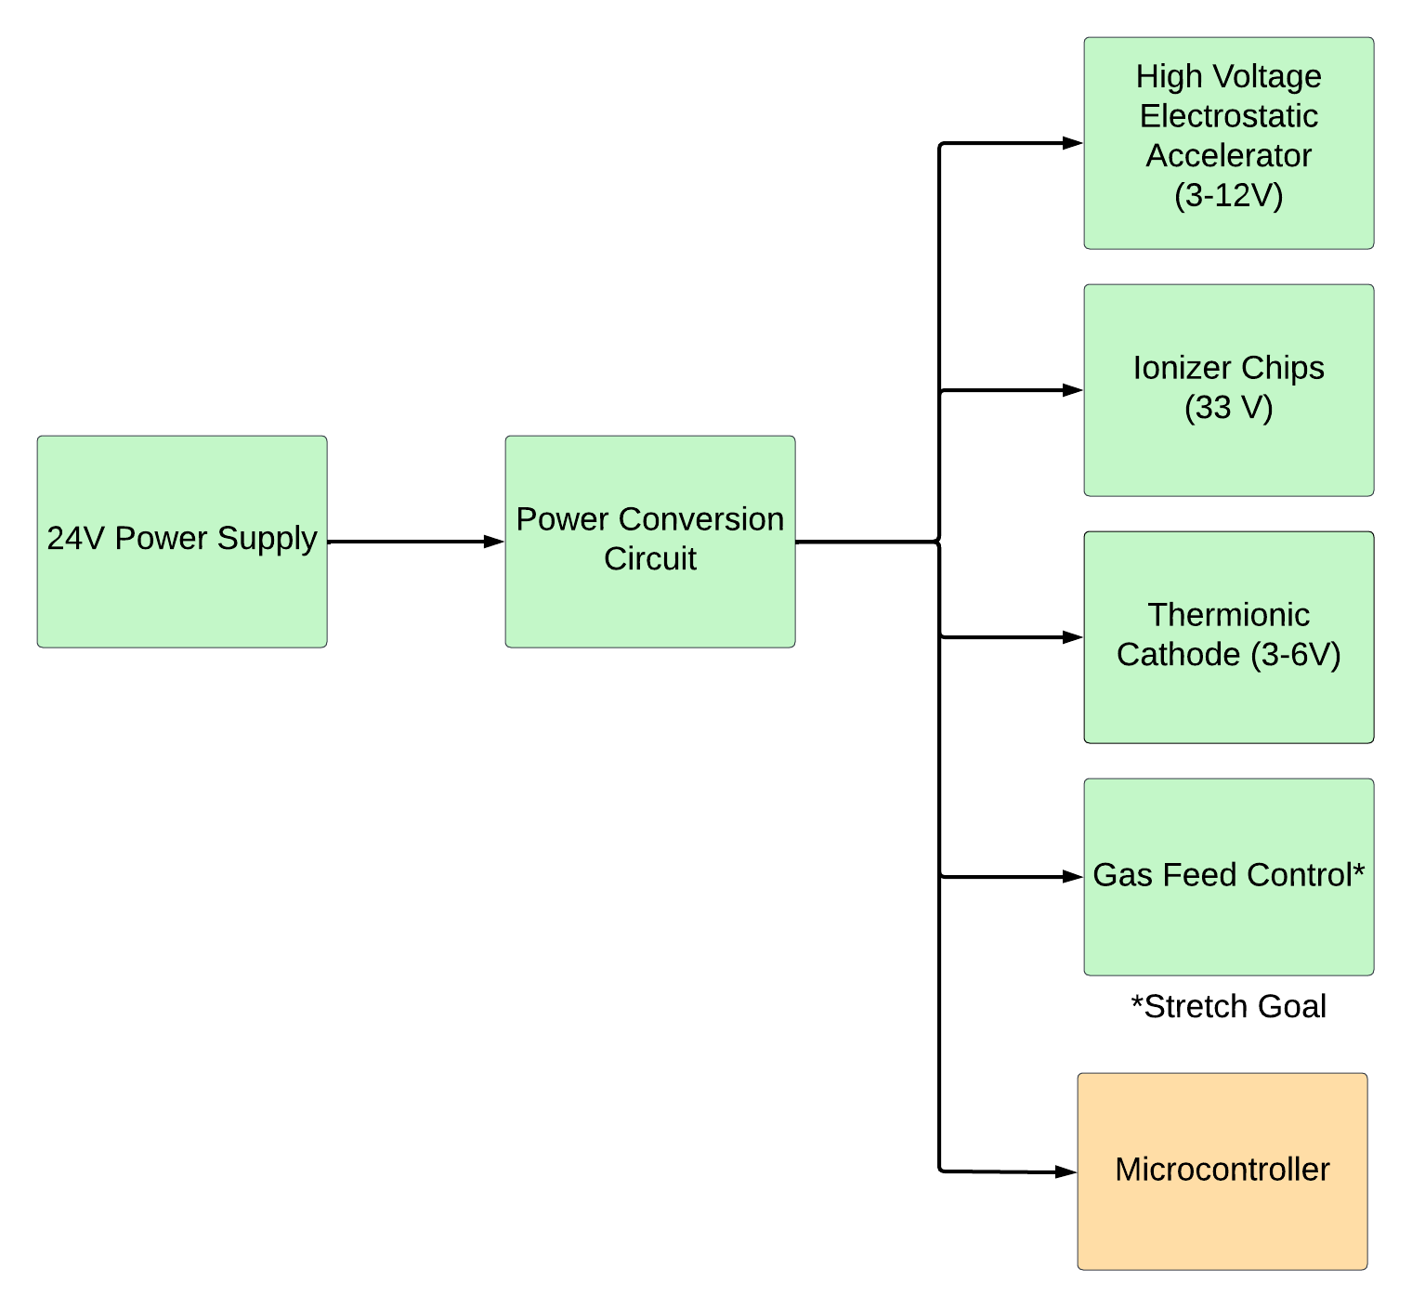

Figure 1: Breakdown of the Power Supply Subsystem

Figure 1 shows how the electrical interface of the RIOT Drive shall work. The 24V power supply shall go through a voltage converter and supply the voltages to the components as shown in Figure 1.

## ***Primary Input Power***

The primary input power that would provide power to the CubeSat would be the spacecraft, assuming it would provide a voltage of 24 VDC. The power budget for the power supply shall be 25 W plus the power for the ionizer chip.

## ***Voltage and Current Levels***

The power supply system shall be designed to output the required power and voltage criteria for the components within the CubeSat. The table below lists the necessary voltage and power requirements needed from the power supply circuit to provide power to the necessary components for the CubeSat.

| **Component** | **Voltage (V)** | **Current (A)** | **Power (W)** |
| --- | --- | --- | --- |
| High Voltage Electrostatic Accelerator | 3-12 | N/A | N/A |
| Thermionic Cathode | 3-6 | 0.3-1 | 1-3 |
| Ionizer Chips | 33 | 0.62 | ~21 |
| Digital-to-Analog Converter | 3.3 | 0.3 | 1 |
| Microcontroller | 3.3 | 0.3 | 1 |

Table 3: Voltage and Power for Components

## ***Signal Interfaces***

The microcontroller shall be mounted on a PCB, and shall be wired to controls for the pulse charger, thermionic cathode, ionizer chips. The gas feed control will be compared by an ADC, and the output value will be transmitted to the gas feed control by the DAC.

## ***User Control Interface***

No user interface was specified as required by the customer because the project is a prototype to prove that the RIOT Drive accelerator, shielding, and power circuit functions.

# **Communications / Device Interface Protocols**

## ***Prototype Interface***

Our prototype will have parts of the system, such as the gas feed valve and high-voltage pulser, interface and communicate with the microcontroller. The circuit board will have test points for voltage probes in critical locations for the user to identify issues with the performance. A space-ready prototype would include a communication system which would be housed inside another CubeSat unit, and is outside the scope of our design.

## ***Use in Spacecraft***

While our prototype will have an internal microcontroller, commercialized systems of the RIOT Drive would rely on the onboard computers of the spacecraft for system control.

CubeSat EM Material Discharge Eval

Joshua Feldman

Michael Kim

Ian Poynter

Alejandro Torres

**Execution and Validation Plan**

REVISION – 1

3 December 2023

**Execution Plan**

| ***Execution Plan*** | | ***Schedule*** | | | | | | | | | | | | | | | | |
| --- | --- | --- | --- | --- | --- | --- | --- | --- | --- | --- | --- | --- | --- | --- | --- | --- | --- | --- |
|  | **Owner** | **SEP** | | | | **OCT** | | | | **NOV** | | | | | **DEC** | | | |
| W1 | W2 | W3 | W4 | W1 | W2 | W3 | W4 | W1 | W2 | W3 | W4 | W5 | W1 | W2 | W3 | W4 |
|  |  |  |  |  |  |  |  |  |  |  |  |  |  |  |  |  |
| Research for PCB Designing | Alejandro |  |  |  |  |  |  |  |  |  |  |  |  |  |  |  |  |  |
| Find Parts & Simulate Circuits | Alejandro |  |  |  |  |  |  |  |  |  |  |  |  |  |  |  |  |  |
| Start PCB Designing | Alejandro |  |  |  |  |  |  |  |  |  |  |  |  |  |  |  |  |  |
| Order Parts | Alejandro |  |  |  |  |  |  |  |  |  |  |  |  |  |  |  |  |  |
| Finish Designing PCB | Alejandro |  |  |  |  |  |  |  |  |  |  |  |  |  |  |  |  |  |
| Order PCB | Alejandro |  |  |  |  |  |  |  |  |  |  |  |  |  |  |  |  |  |
| Debug and Test PCB | Alejandro |  |  |  |  |  |  |  |  |  |  |  |  |  |  |  |  |  |
| Aluminum stock for Chassis procured | Ian |  |  |  |  |  |  |  |  |  |  |  |  |  |  |  |  |  |
| Engineering Drawings of CubeSat Complete | Ian |  |  |  |  |  |  |  |  |  |  |  |  |  |  |  |  |  |
| Design of CubeSat chassis parts with CAD | Ian |  |  |  |  |  |  |  |  |  |  |  |  |  |  |  |  |  |
| Fabrication of designed parts for CubeSat chassis | Ian |  |  |  |  |  |  |  |  |  |  |  |  |  |  |  |  |  |
| CubeSat standards verification for fabricated parts | Ian |  |  |  |  |  |  |  |  |  |  |  |  |  |  |  |  |  |
| Construction of CubeSat chassis | Ian |  |  |  |  |  |  |  |  |  |  |  |  |  |  |  |  |  |
| Chassis completely built and ready for integration | Ian |  |  |  |  |  |  |  |  |  |  |  |  |  |  |  |  |  |
| Research materials with required properties. | Michael |  |  |  |  |  |  |  |  |  |  |  |  |  |  |  |  |  |
| Finalize the three materials | Michael |  |  |  |  |  |  |  |  |  |  |  |  |  |  |  |  |  |
| Design geometries for structure of accelerator. | Michael |  |  |  |  |  |  |  |  |  |  |  |  |  |  |  |  |  |
| Finalize the three designed geometries. | Michael |  |  |  |  |  |  |  |  |  |  |  |  |  |  |  |  |  |
| Construct combinations with materials/geometries. | Michael |  |  |  |  |  |  |  |  |  |  |  |  |  |  |  |  |  |
| Order Microcontroller | Joshua |  |  |  |  |  |  |  |  |  |  |  |  |  |  |  |  |  |
| Create circuit schematic in Altium | Joshua |  |  |  |  |  |  |  |  |  |  |  |  |  |  |  |  |  |
| Create and route PCB | Joshua |  |  |  |  |  |  |  |  |  |  |  |  |  |  |  |  |  |
| Order PCB | Joshua |  |  |  |  |  |  |  |  |  |  |  |  |  |  |  |  |  |
| Familiarize with coding environment | Joshua |  |  |  |  |  |  |  |  |  |  |  |  |  |  |  |  |  |
| Configure variables and outputs to enable thermionic cathode, ionizer chip, and pulse charger | Joshua |  |  |  |  |  |  |  |  |  |  |  |  |  |  |  |  |  |
| Confgure PIC and DAC interface | Joshua |  |  |  |  |  |  |  |  |  |  |  |  |  |  |  |  |  |
| Program BIT system | Joshua |  |  |  |  |  |  |  |  |  |  |  |  |  |  |  |  |  |
| Microcontroller Debugging | Joshua |  |  |  |  |  |  |  |  |  |  |  |  |  |  |  |  |  |
| CONOPS | Group |  |  |  |  |  |  |  |  |  |  |  |  |  |  |  |  |  |
| FSR/ICD | Group |  |  |  |  |  |  |  |  |  |  |  |  |  |  |  |  |  |
| Execution and Validation Plan | Group |  |  |  |  |  |  |  |  |  |  |  |  |  |  |  |  |  |
| Order Parts | Group |  |  |  |  |  |  |  |  |  |  |  |  |  |  |  |  |  |
| Introduction Presentation | Group |  |  |  |  |  |  |  |  |  |  |  |  |  |  |  |  |  |
| Update Presentation | Group |  |  |  |  |  |  |  |  |  |  |  |  |  |  |  |  |  |
| Final Presentation | Group |  |  |  |  |  |  |  |  |  |  |  |  |  |  |  |  |  |
| Demo | Group |  |  |  |  |  |  |  |  |  |  |  |  |  |  |  |  |  |
| Final Report | Group |  |  |  |  |  |  |  |  |  |  |  |  |  |  |  |  |  |
|  | |  | Behind Schedule | | | | | | | | | | | | | | | |
|  | Not started, on schedule | | | | | | | | | | | | | | | |
|  | In progress | | | | | | | | | | | | | | | |
|  | Completed | | | | | | | | | | | | | | | |

**Validation Plan**

| **Paragraph** | **Task** | **Specification** | **Completed** | **Responsible Engineer** |
| --- | --- | --- | --- | --- |
| 3.2.3.1.1 Power Consumption | Max Power | Measure power for each component ensuring below power budget of 50W | Incomplete | Alejandro Torres |
| 3.2.3.1.2 Input Voltage Level | Voltage Supply | Voltage supply is 24 V | Completed | Alejandro Torres |
| 3.2.3.2.1 Output Voltages | Microcontroller Supply Voltage | Microcontroller is supplied a voltage of 3.3V/5V | Completed | Alejandro Torres |
| 3.2.3.2.1 Output Voltages | Thermionic Cathode Supply Voltage | Supplied Voltage between 3-6V | Completed | Alejandro Torres |
| 3.2.3.2.1 Output Voltages | Ionizer Chips Supply | 33V Supplied | Incomplete | Alejandro Torres |
| 3.2.3.2.1 Output Voltages | Output Voltage | Measure output voltages to be supplied for each component | Completed | Alejandro Torres |
| 3.2.3. Dimensions of Power Supply | PCB Design | width & length : <100cm  height: <20cm | Completed | Alejandro Torres |
| 3.1 Weight | PCB Design | <0.2 kg | Completed | Alejandro Torres |
| 3.2.2.2 Volume Envelope | Prototype Footprint | Footprint of our prototype fits CubeSat size regulations (10x10x10 cm) | Completed | Ian Poynter |
| 3.2.2.1 Mass | Prototype Weight | Weight of the Chassis does not exceed 200 g on its own | Completed | Ian Poynter |
| 3.2.2.3 Mounting | Electronics Mounting | Power Supply and Microcontroller PCB has space for mounting to the chassis | Completed | Ian Poynter |
| 3.2.2.3 Mounting | Accelerator Plate Mounting | Mounting for accelerator plate is available and not blocked by chassis | Completed | Ian Poynter |
| 3.2.2.2 Volume Envelope | CubeSat Regulations | The prototype chassis fits all CubeSat standards not neglected due to design restraints or to be tested in the future | Completed | Ian Poynter |
| 3.2.2.4 Accelerator Geometry and Material | Geometry (Volume) | Accelerator will have around similar volume as desired volume (10 cm x 10 cm x ~2cm) to fit inside chassis | Completed | Michael Kim |
| 3.2.2.4 Accelerator Geometry and Material | Geometry (Shape) | 3 geometries will extend retention without additional charging and protect spacecraft/ionizer from it | Completed | Michael Kim |
| 3.2.2.4 Accelerator Geometry and Material | Material | 3 materials that handle space launch, radiation stress, and electric flux from space plasma will be tested | Completed | Michael Kim |
| 3.2.2.4 Accelerator Geometry and Material | Combinations | All 9 combinations will be constructed for testing for electrostatic potential. | In Progress | Michael Kim |
| 5.3 Signal Interfaces | Fuel Valve | Verify microcontroller compares and regulates fuel pressure and flow. | - | Joshua Feldman |
| 5.3 Signal Interfaces | Microcontroller | Verify microcontroller properly activates pulse charger, ionizer, and thermionic cathode. | - | Joshua Feldman |
| 5.3 Signal Interfaces | Microcontroller | All connections to the microcontroller are properly set up. | - | Joshua Feldman |
| 6.1 Prototype Interface | Microcontroller | Microcontroller can be tested with test bench | - | Joshua Feldman |
| 6.1 Prototype Interface | Microcontroller | BIT system properly catches exceptions thrown. | - | Joshua Feldman |

CubeSat EM Material Discharge Eval

Joshua Feldman

Michael Kim

Ian Poynter

Alejandro Torres

**Subsystem Reports**

REVISION – 1

3 December 2023

Functional System Requirements

for

CubeSat EM Material Discharge Eval

Prepared by:

_____________________________

Author Date

Approved by:

_____________________________

Project Leader Date

_____________________________

John Lusher, P.E. Date

_____________________________

T/A Date

**Change Record**

| **Rev.** | **Date** | **Originator** | **Approvals** | **Description** |
| --- | --- | --- | --- | --- |
| - | 9/28/2023 | Ian Poynter |  | Draft Release |
| 1 | 12/3/2023 | Ian Poynter |  | End of Semester Revision |

**Table of Contents**

**Table of Contents 4**

**List of Tables 5**

**List of Figures 6**

**1.** **Introduction 7**

**2.** **Power Supply Circuit Subsystem Report 8**

2.1. Subsystem Introduction 8

2.2. Subsystem Details 8

2.3. Subsystem Validation 9

2.4. Failure Analysis of Subsystem 13

2.5. Subsystem Conclusion 14

**3.** **Microcontroller Subsystem Report 15**

3.1. Subsystem Introduction 15

3.2. Subsystem Details 15

3.3. Subsystem Validation 16

3.4. Subsystem Failures 18

3.5. Subsystem Conclusion 18

**4.** **CubeSat Chassis Subsystem Report 19**

4.1. Subsystem Introduction 19

4.2 CubeSat Standards Verification…………………………………………………………… 19

4.3. Chassis Testing and Future Work………………………………………………………… 24

**5.** **High Potential Accelerator Modeling Subsystem Report 25**

5.1. Subsystem Introduction 25

5.2. Subsystem Details 25

5.3. Subsystem Validation 25

5.4. Subsystem Failures 27

5.5. Subsystem Conclusion 27

**List of Tables**

**Table 1: Neglected CubeSat Standards 7**

**Table 2: Measurement of Plates 7**

**List of Figures**

**Figure 1: Power Supply Circuit Subsystem Block Diagram 8**

**Figure 2: Soldered PCB 9**

**Figure 3: Buck Converter Simulation 10**

**Figure 4: Buck Converter with LM2595 10**

**Figure 5: Buck Converter Output from PCB 11**

**Figure 6: Boost Converter with LM2588 11**

**Figure 7: Boost Converter Simulation 12**

**Figure 8: Boost Converter Output from PCB 12**

**Figure 9: Mass of PCB 13**

**Figure 10: Block Diagram of Microcontroller Subsystem 15**

**Figure 11: Fully Soldered Circuit Board 16**

**Figure 12: User Interface and Terminal on Laptop 17**

**Figure 13: Commands to activate switches on terminal 17**

**Figure 14: Commands to send data over SPI and reading from ADC 17**

**Figure 15: 1U CubeSat Schematic with Dimensions 21**

**Figure 16: Engineering Drawing for Corner Assembly 21**

**Figure 17: Engineering Drawing for Chassis Top 22**

**Figure 18: Completed Chassis Assembly in SOLIDWORKS 22**

**Figure 19: CubeSat Chassis 24**

**Figure 20: Circular Plates (*Left to Right*: Polypropylene, HDPE, PTFE) 26**

**Figure 21: Hemispheres (*Left to Right*: Polypropylene, HDPE, PTFE) 26**

**Figure 22: Cones (*Left to Right*: Polypropylene, HDPE, PTFE) 26**

# 

# **Introduction**

The RIOT Drive is broken down into the power, microcontroller, chassis, and accelerator modeling each of which is designed and tested to fit the standards of the CubeSat which are crucial to the CubeSat’s design. Through this project, our goal is to design a prototype and provide working components to conduct the first tests for the development of the RIOT Drive. The purpose of this document is to discuss the divided subsystems and the validation processes associated with these subsystems.

# **Power Supply Circuit Subsystem Report**

# ***Subsystem Introduction***

The power supply circuit subsystem is designed to provide power to the necessary components within the CubeSat. The spacecraft’s power supply powers the circuit which is then bucked or boosted to fit the required voltages of each component. The power supply circuit was tested to determine if the system could provide the required power to each component and to ensure the system was stable.

# ***Subsystem Details***

A block diagram of the power supply circuit is shown below.

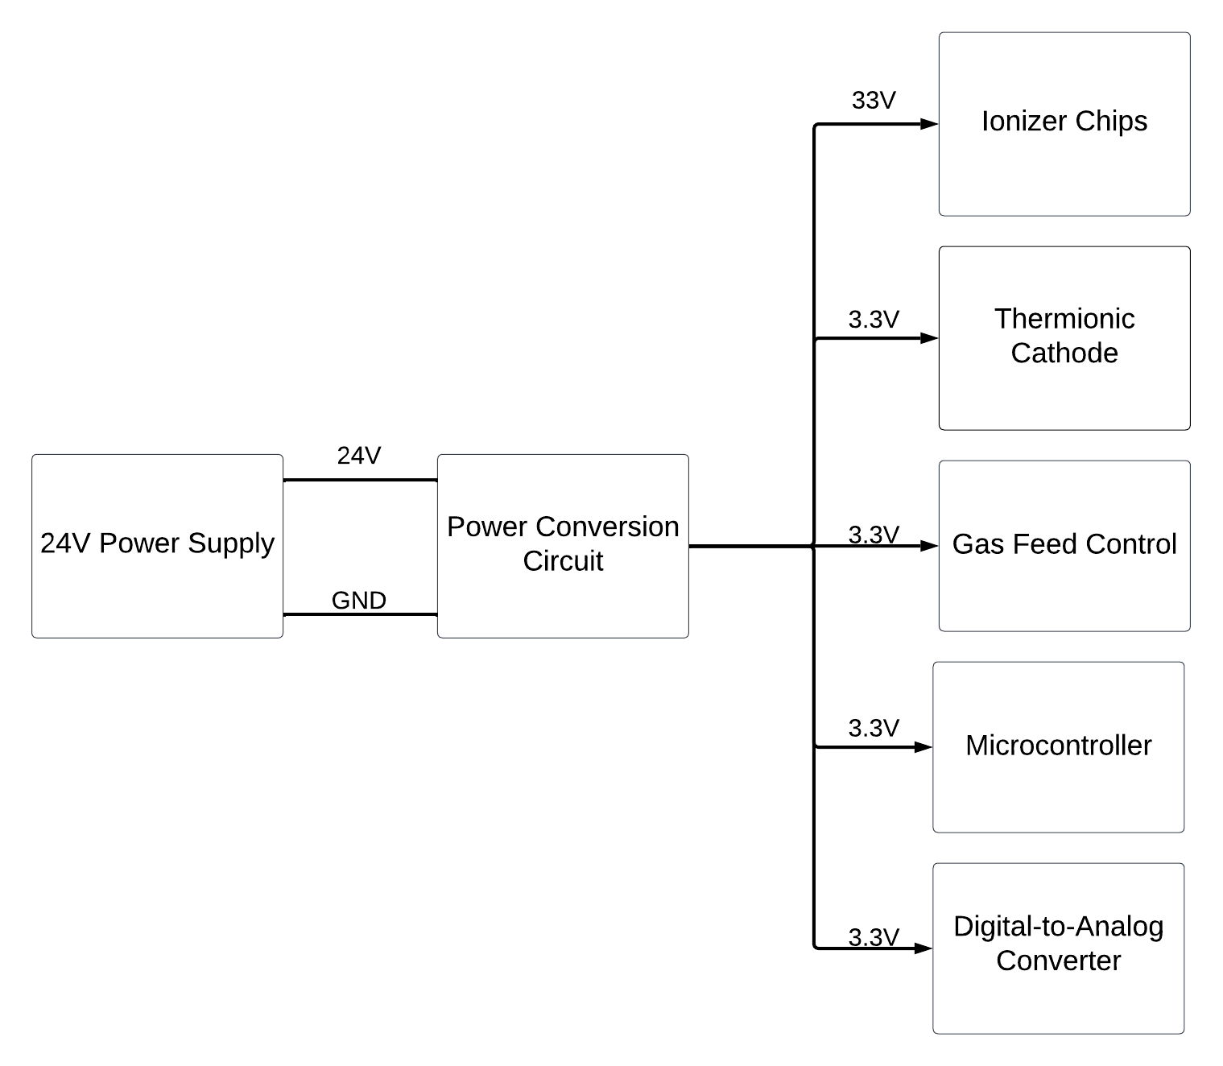

**Figure 1: Power Supply Circuit Block Diagram**

The power conversion circuit consists of a buck converter which would receive the 24V input and then buck it down to 3.3V to provide power to the components as seen in Figure 1. The power conversion circuit also consists of a boost converter which would also receive the 24V input and boost it up to 33V to provide power to the ionizer chips. Figure 2 shows a soldered PCB that would convert the 24V input to their respective voltages, either 33V or 3.3V. Pin headers were used to output the 3.3V from the buck converter to power the thermionic cathodes, two pins are needed for the input and the ground. For the boost converter output, a terminal block was used to power the ionizer chips.

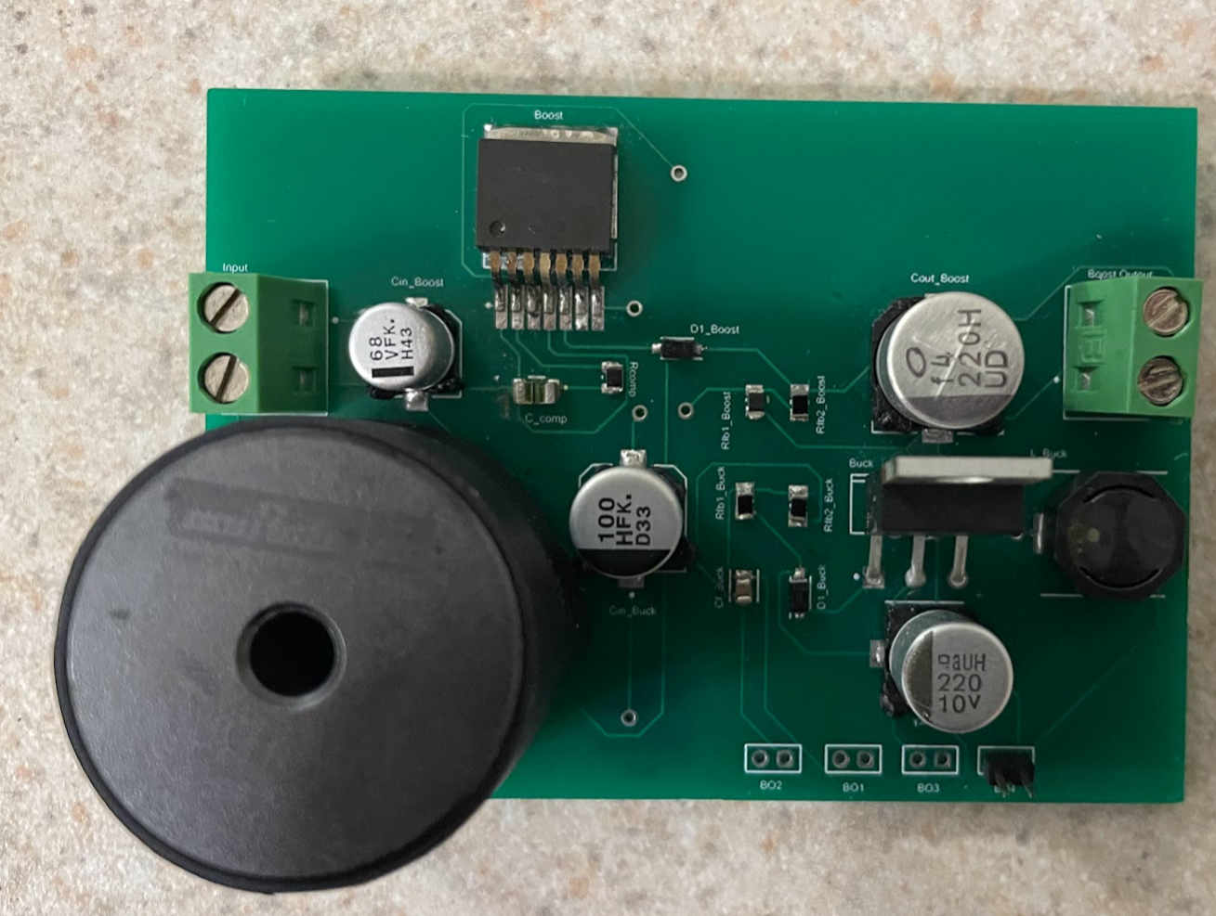

**Figure 2: Soldered PCB**

# ***Subsystem Validation***

This section will discuss the validation that was done while designing and soldering the power circuit. Since a spacecraft’s power supply is not used to validate, a DC power supply was used to validate with the 24V input to ensure that the power circuit works as intended.

To ensure that one part of the circuit would work, simulations were conducted to receive the 3.3V output. By using the LTSpice software the buck converter circuit has been simulated with the necessary circuit components to receive the 3.3V output. The simulation of the buck converter is shown below with the circuit configuration.

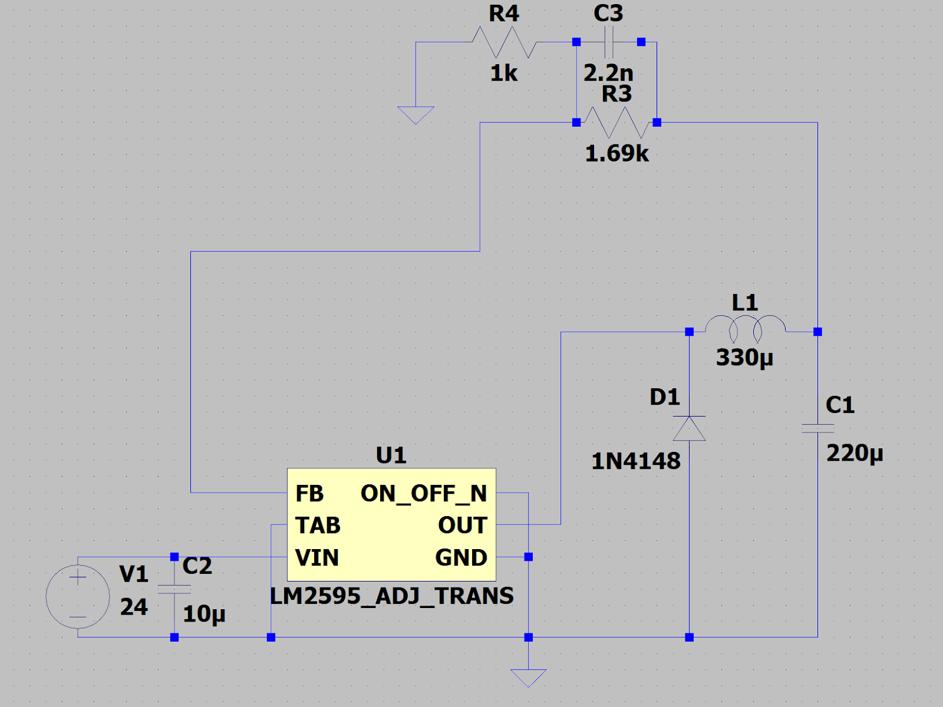

**Figure 3: Buck Converter with LM2595**

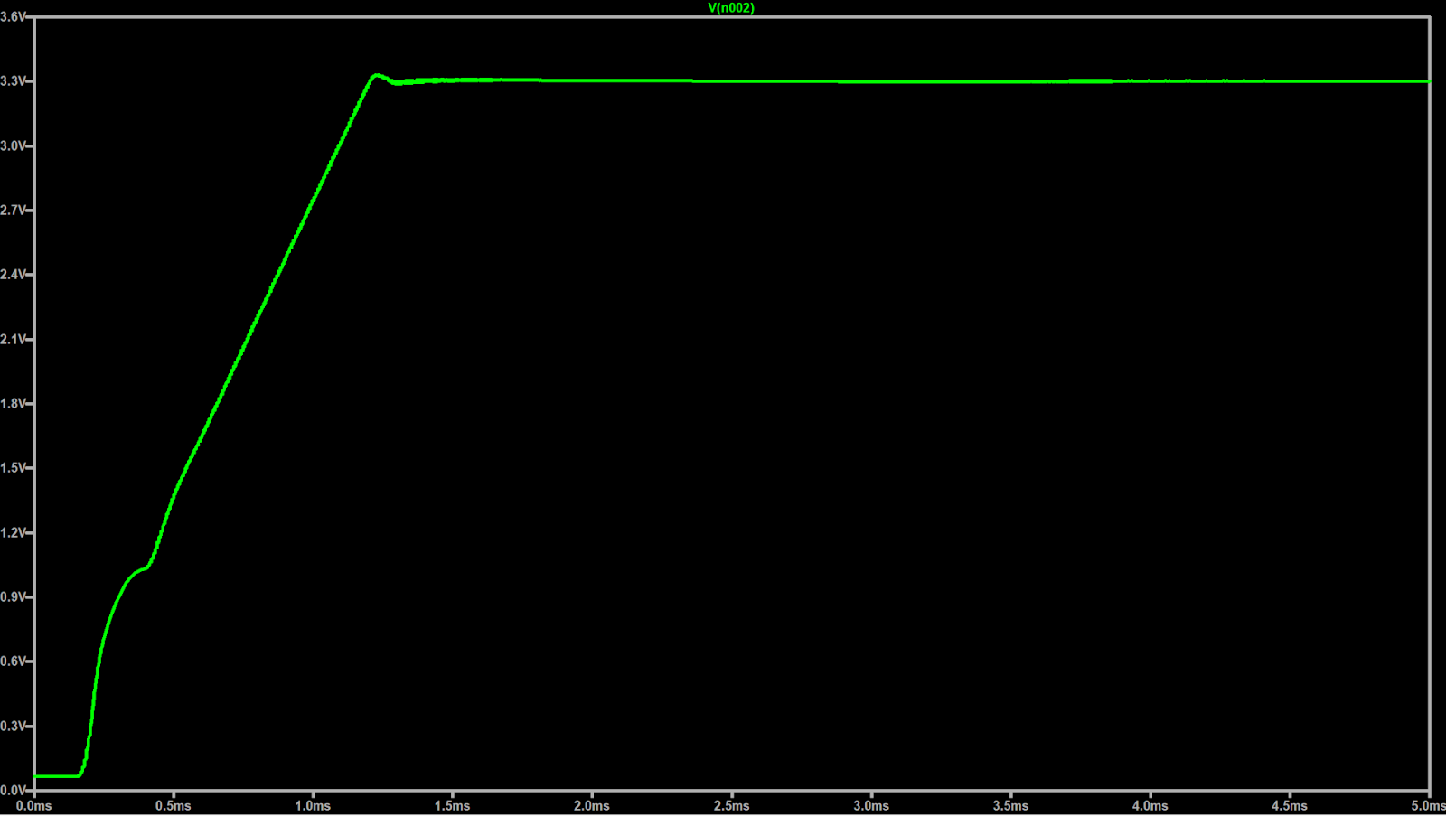

**Figure 4: Buck Converter Simulation**

The buck converter was then tested to see if this part of the circuit would convert the voltage from 24V to 3.3V. The results that were recorded are shown on a multimeter below.  
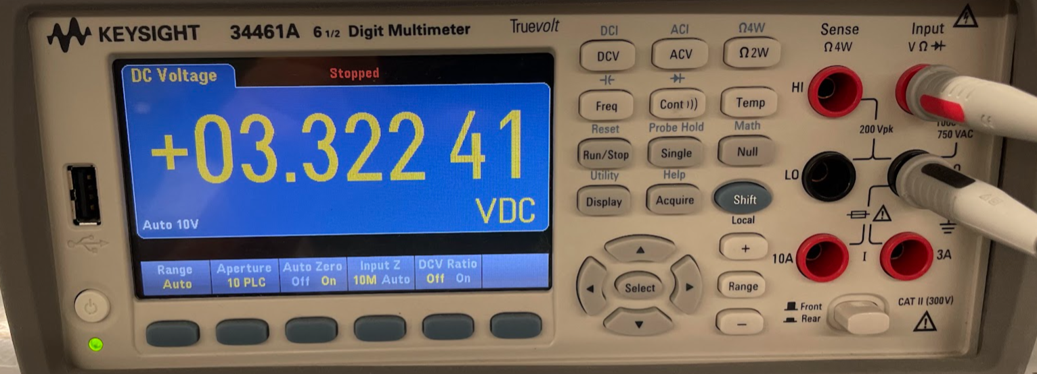

**Figure 5: Buck Converter Output from PCB**

To test if the boost converter works properly, simulations were found on the Texas Instruments’ WeBench website to ensure that this part of the circuit provided the necessary voltage required. The simulations that were found are shown in the figure below.

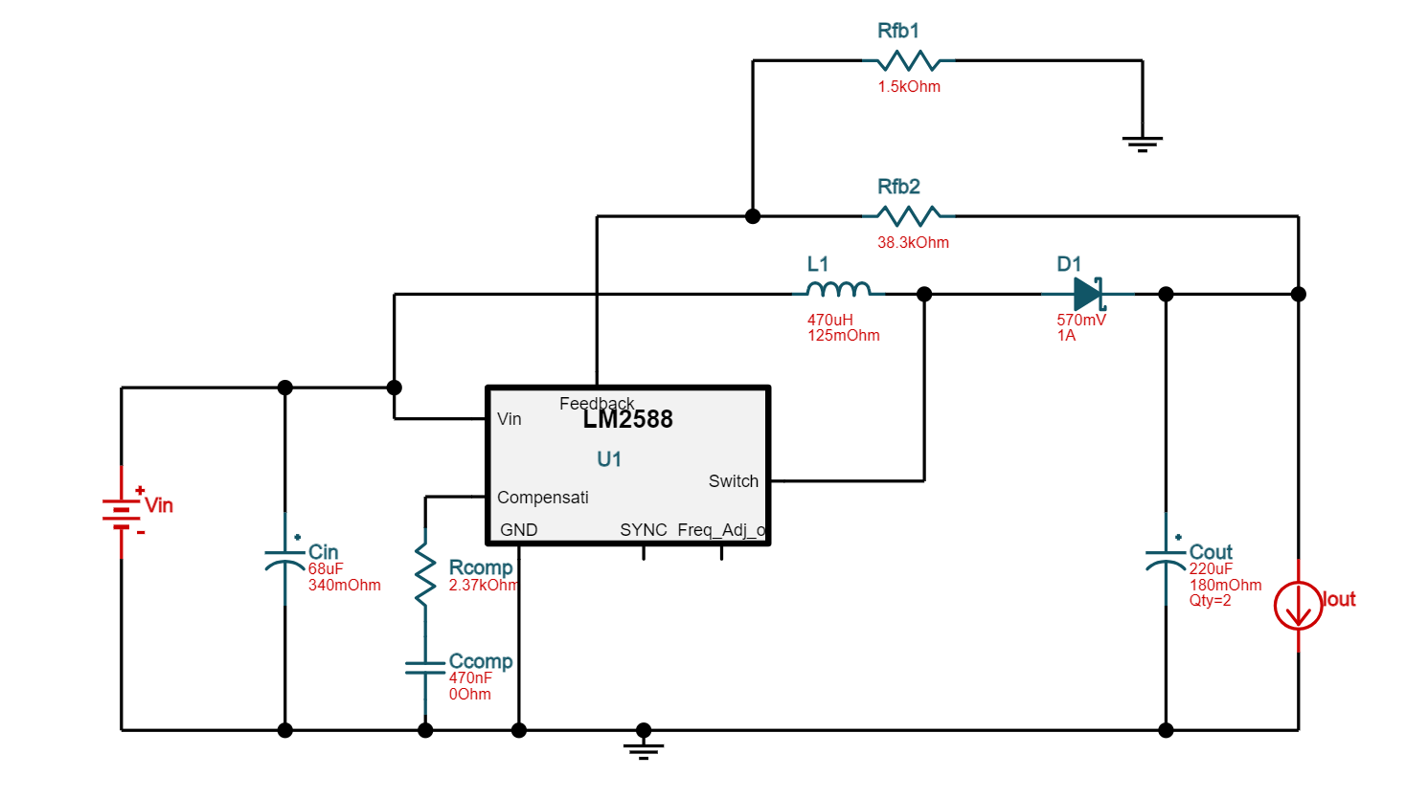

**Figure 6: Boost Converter with LM2588**

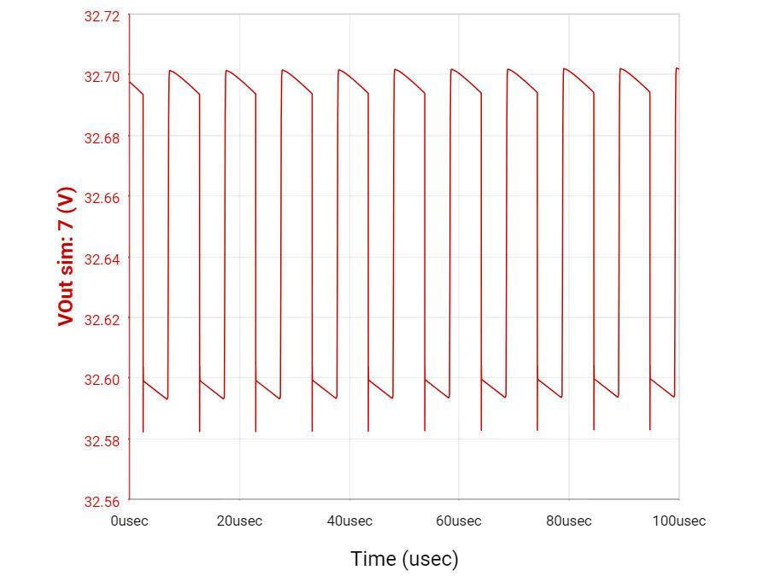

**Figure 7: Boost Converter Simulation**

As the boost converter for the PCB was tested, the recorded output voltage was about 24V as shown below which is not the voltage needed.

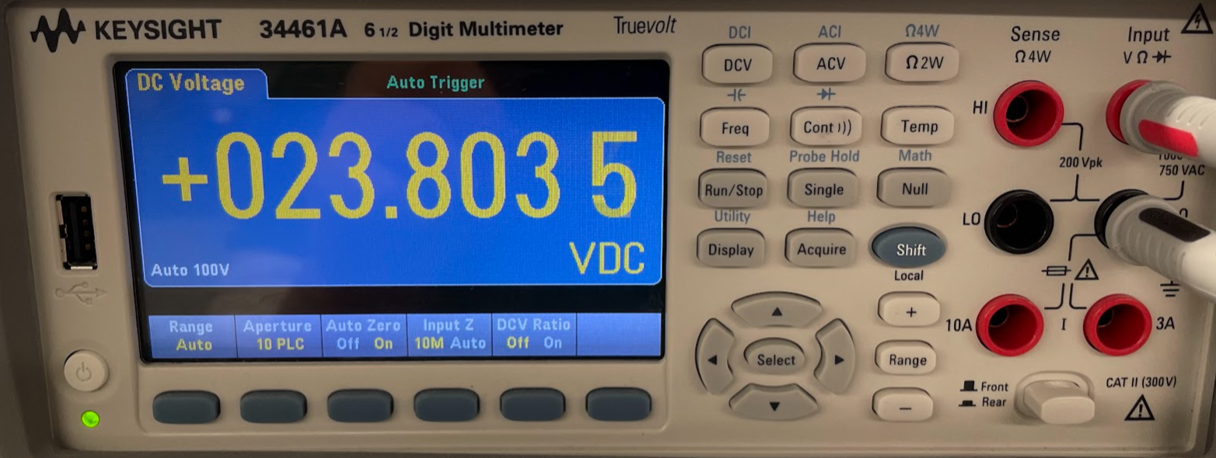

**Figure 8: Boost Converter Output from PCB**

As the PCB was designed and soldered, the configuration was then weighed to see if the mass was less than 200g. The mass that was recorded was 96 grams which is well within our goal.

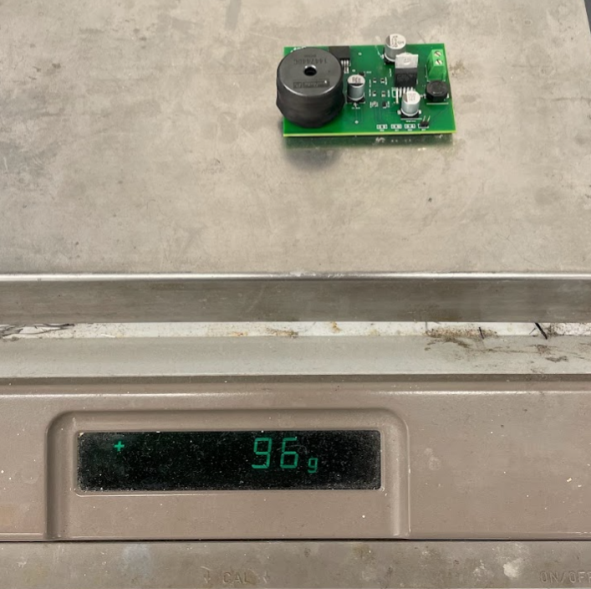

**Figure 9: Mass of the PCB**

# ***Failure Analysis of Subsystem***

As mentioned in the previous section, the boost converter was only able to output about 24V. One thing that was changed to try and fix this problem was to change the output capacitance that was required for this configuration since the circuit did not have the correct capacitance before. As the capacitance was changed, the circuit would still receive the same 24V output. One problem that might cause this is that one of the pins on the IC is not grounded, so this may be why the circuit does not reach the required output voltage. Another problem that may cause this is some of the components may not be completely soldered onto the board, or some of the components that are used need to be compatible with the configuration itself. One way to challenge these problems is to find a circuit that can be simulated on LTSpice instead of using the WEBENCH Power Designer software for simulations. If simulations were performed on LTSpice then this would provide a clearer picture of how the boost converter would look like and which components would best fit the configuration to receive an output of 33V.

# ***Subsystem Conclusion***

For this subsystem, the buck converter was shown to work correctly. The buck converter will ensure that it provides the necessary power to each component as mentioned previously. As this system is integrated into the other systems, it will ensure that the power is maintained within the CubeSat. It will also ensure that it will provide stability to the components and the whole system in general. This subsystem will also work with the microcontroller subsystem to have all the hardware components within the CubeSat maintain stability and provide power to the necessary components of the system as a whole.

# **Microcontroller Subsystem Report**

# ***Subsystem Introduction***

The microcontroller subsystem of the RIOT Drive prototype is designed to control the components of the RIOT Drive. This subsystem is intended to control the power delivery to the ionizer chips, the pulse charger, and the thermionic cathodes. It also will read and write a voltage to the gas flow controller to determine the valve pressure, or to set the pressure. The microcontroller is also designed to take commands through USART to set those values, or display information.

# ***Subsystem Details***

**Figure 10: Block Diagram of Microcontroller Subsystem**

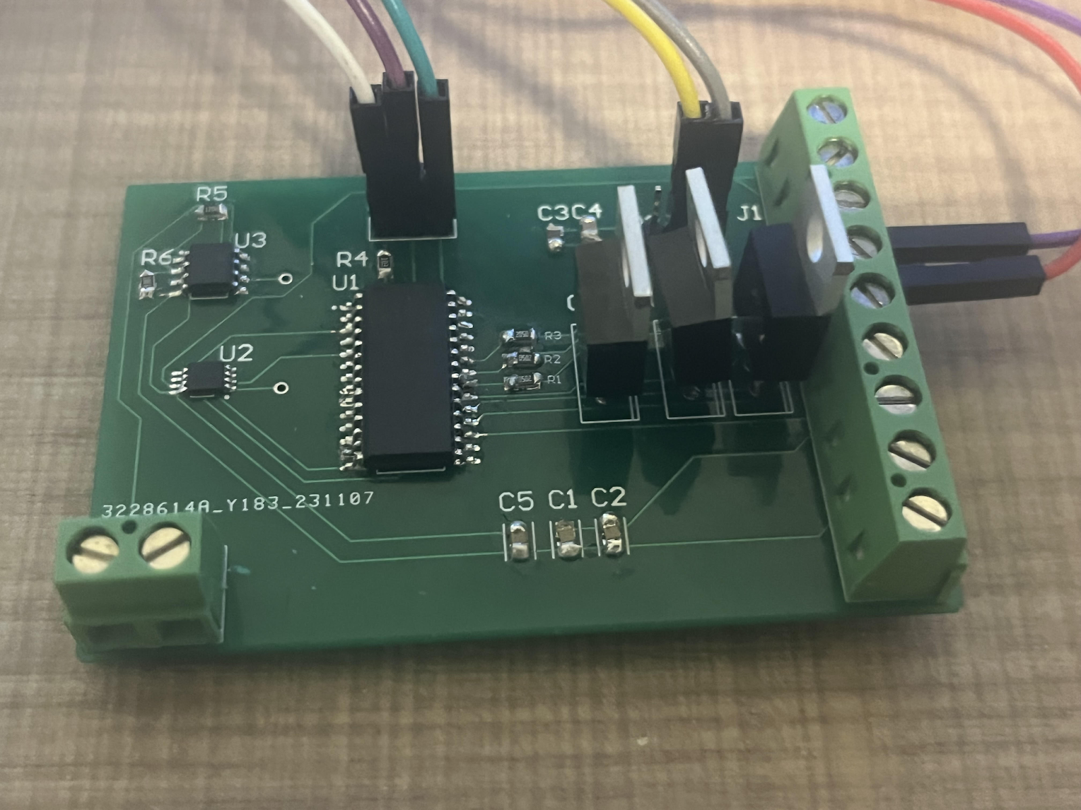

**Figure 11: Fully Soldered Circuit Board**

The microcontroller chosen is a PIC18F24Q10 because it is robust to voltage surges which may be present with the high voltage in this project, and because the RIOT Drive does not require a high frequency processor. The microcontroller sends and receives data over USART. To switch the power to the pulse charger, thermionic cathode and ionizer chips on and off, a command is sent over USART to power the base of a transistor, allowing the flow of current through the wire. The transistors chosen have a high current and voltage tolerance because the ionizer requires high voltage to operate, and the pulse charger requires high current. The ADC built into the PIC is used to read the voltage from the gas flow controller, and the voltage along with the pressure corresponding to that voltage are displayed on a connected laptop when the correct command is issued. The voltage sent to the gas flow controller is done through an external DAC. The DAC chosen is the MSP4822 because it is a 12-bit DAC that can be communicated with over SPI which the PIC supports. The DAC then outputs to a non-inverting opAmp to boost the voltage for the gas flow controller. The microcontroller was programmed in MPLAB X IDE, and the PICkit 5 was used to program and debug the microcontroller.

* 1. ***Subsystem Validation***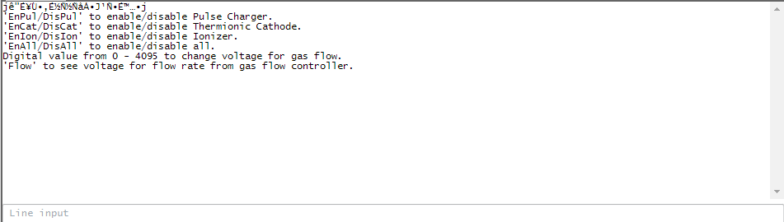

**Figure 12: User Interface and Terminal on Laptop**

The PIC outputs a short set of commands that can be sent to the microcontroller. The first 4 lines can set the voltage of the base of the 3 transistors to switch the power on and off. Sending a number will send that value through SPI to the DAC. The last command will return the voltage and digital value from the ADC peripheral of the microcontroller.

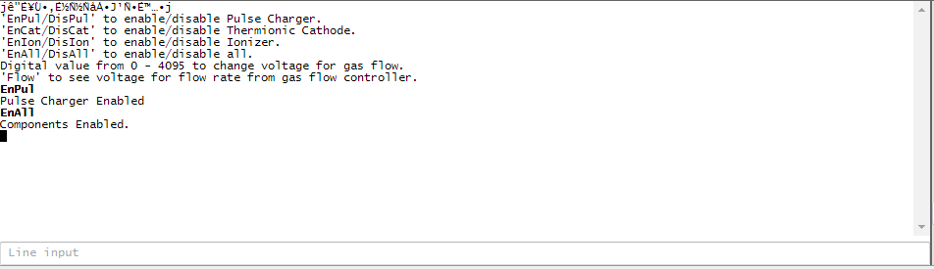

**Figure 13: Commands to activate switches on Terminal**

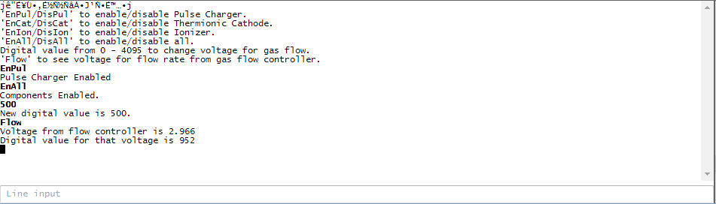

**Figure 14: Commands to send data over SPI and reading from ADC**

* 1. ***Subsystem Failures***

The SPI write to the DAC is not working currently. The function does not break the program, the SPI buffer is being written to, and the configuration bits for the DAC are properly set, but the DAC doesn’t have any output. Between now and 404, I will look at the code for the SPI, and try to get an output from the DAC. I will also double-check the connections on the PCB and re-solder the board if necessary.

* 1. ***Subsystem Conclusion***

The microcontroller subsystem properly interfaces with most of the required components specified by the design constraints. The transistors properly function as switches and the ADC functions. The only issue with SPI should be resolved after additional testing and debugging, and the subsystem will be on track for 404.

# **Cubesat Chassis Subsystem Report**

# ***Subsystem Introduction***

The chassis for our CubeSat prototype is meant to serve as a testing ground for the electrical properties of the RIOT Drive and will serve as a prototype for mounting locations of parts for future iterations of the design, as well as to test the insulation for the accelerator plates for arcing. The chassis was constructed according to the CubeSat Design Specifications, as well as using aerospace-grade Aluminum 7075 for the construction.

# ***CubeSat Standards Verification***

In this section, we will go over the CubeSat Design Specification. The CubeSat platform and its respective standards are set by California Polytechnic State University. For this evaluation, we are referencing Revision 14.1. With the large number of regulations pertaining to the space industry, many of these specifications do not apply to our prototype, or components that would be impacted by these standards have not been fully developed by the Capstone Team or Orbital Arc. Non-referenced standards and explanations as to why each standard was neglected are provided in Section 2.2.4.

**4.2.1. General Specifications**

2.1.1 All parts shall remain attached to the CubeSats during launch, ejection, and operation.

2.1.7 CubeSat materials shall satisfy low out-gassing criteria, as defined in

2.1.7.1 and 2.1.7.2, to prevent contamination of other spacecraft during integration, testing, and launch.

2.1.7.1 CubeSats materials shall have a Total Mass Loss (TML) of less than or equal to 1.0 %

2.1.7.2 CubeSat materials shall have a Collected Volatile Condensable Material (CVCM) of less than or equal to 0.1%

For the general specifications of the CubeSat platform, the main specifications our project is concerned with are 2.1.1 and 2.1.7. For specification 2.1.1, the chassis was put through preliminary mechanical testingto ensure solid construction of the chassis. This, plus using design practices such as using lock washers on the fasteners, allows us to confirm the chassis will withstand the stresses of space launch. The chassis will undergo further testing in the future, such as random vibration testing, which will be discussed in Section 4.3. Additionally, materials for the chassis and other components were selected with NASA out-gassing standards in mind. All materials used in the chassis conform to the necessary outgassing requirements specified in 2.1.7.1 and 2.1.7.2.

**4.2.2. Mechanical Specifications**

2.2.1 The CubeSat shall use the coordinate system as defined in Appendix B of the CubeSat Design Specification. The origin of the CubeSat coordinate system is located at the geometric center of the CubeSat.

2.2.3 No components on the sides shall protrude further than 6.5 mm normal to the surface from the plane of the rail.

2.2.5 Rails shall have a minimum width of 8.5mm measured from the edge of the rail to the first protrusion on each face.

2.2.7 The edges of the rails should be rounded to a radius of at least 1 mm.

2.2.8 The ends of the rails on the +/- Z face shall have a minimum surface area of 6.5 mm x 6.5 mm contact area with neighboring CubeSat rails.

2.2.10 Maximum mass for 1U Cubesat to not exceed 2 kg.

2.2.13 Any aluminum CubeSat external surfaces, such as rails and standoffs that are in contact with the dispenser rails, shall be hard anodized to prevent any cold welding within the dispenser.

The mechanical specifications of the CubeSat platform is the most applicable section to our project and chassis. For specification 2.2.1-2.2.9, our CubeSat chassis was designed following the schematics provided in the CubeSat Design Specification and meets all of the referenced standards. The schematics are seen in Figure 12. The engineering drawings for the corner pieces as well as the top and bottom pieces are shown in Figure 13 and Figure 14, respectively. The corner pieces were fabricated using water jet cutting and bent using a brake. The top and bottom pieces were fabricated using a CNC Mill in the FEDC Fabrication Center. Upon measurement, no dimension had more than a 2 mm deviation from the design in the CubeSat specifications. For this prototype, which is to provide a platform for testing, this is well within the acceptable error tolerance for our project. For standard 2.2.10, the weight requirement is for the entire CubeSat satellite. From our sponsors, we required that the chassis consist of no more than10% of the mass requirements. Our chassis weight came in at 132 g, satisfying this requirement. For standard 2.2.13, initial meetings with our sponsor and our capstone team resulted in neglecting the hard anodization requirements due to cost. However, due to the electrical property differences between plain aluminum and hard anodized aluminum (conductor vs. dielectric), our sponsor has decided to hard anodize the chassis for the most accurate testing results.

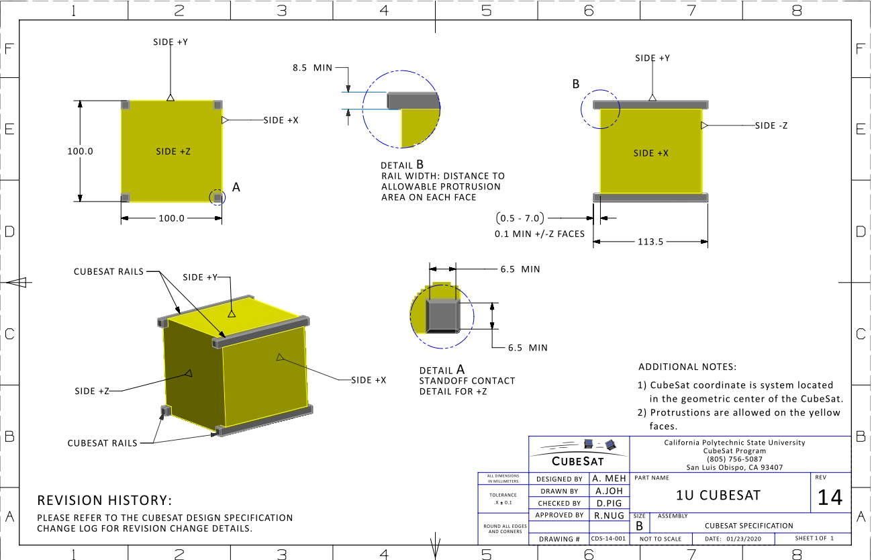

**Figure 15: 1U CubeSat Schematics with Dimensions**

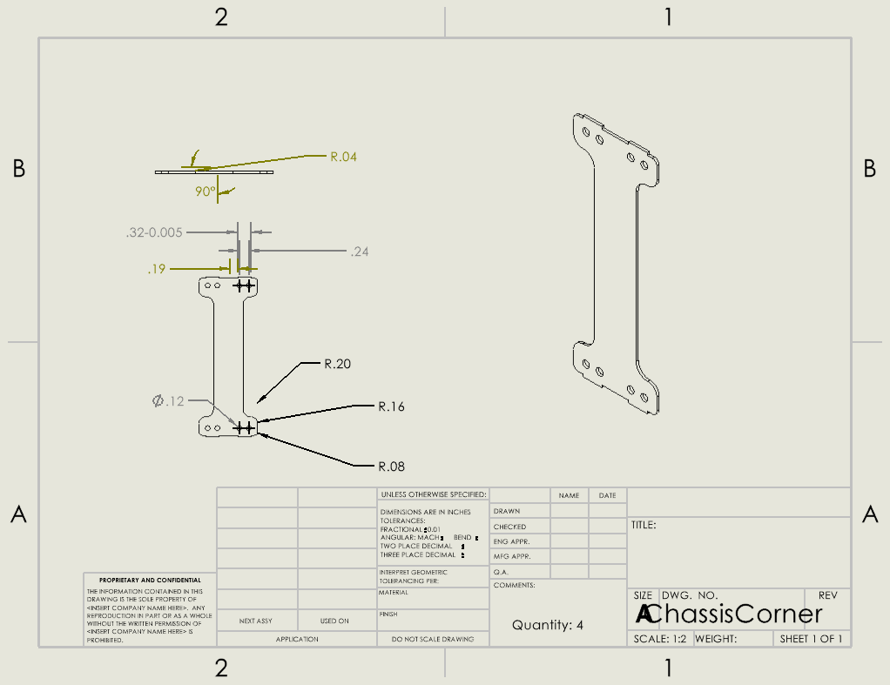

**Figure 16: Engineering Drawing for Corner Assembly**

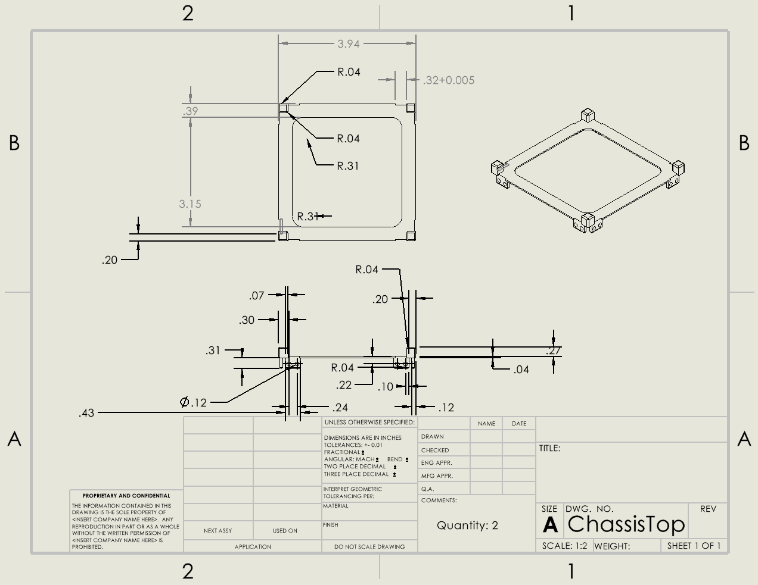

**Figure 17: Engineering Drawing for Chassis Top**

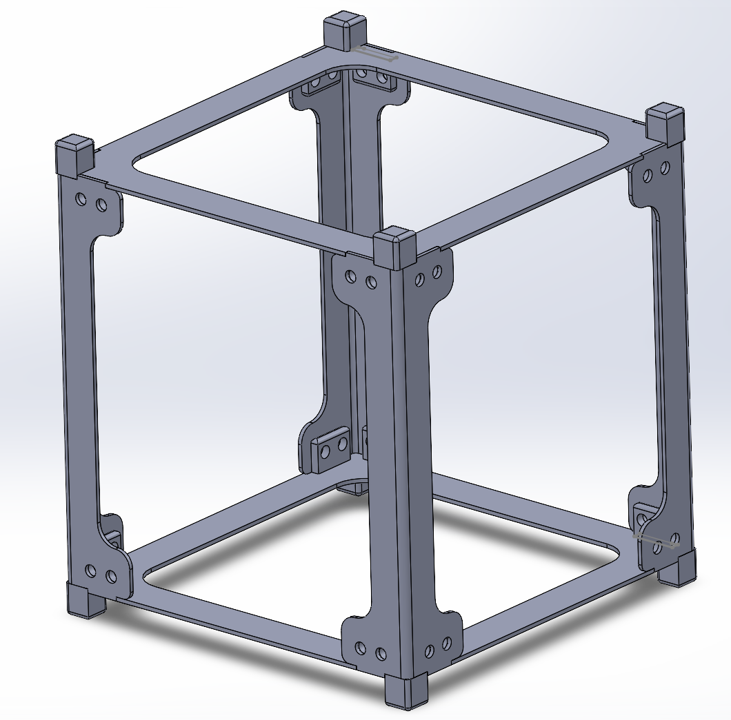

**Figure 18: Completed Chassis Assembly in SOLIDWORKS**

**4.2.3. Electrical and Operational Specifications**

Sections 2.3 and 2.4 of the CubeSat Design Specification cover the electrical and operational specifications of a CubeSat. While our project does utilize electrical components, these specifications pertaining to the electrical components have been neglected at our sponsor’s request. The electrical circuitry is to be considered external to our CubeSat, and the specifications mostly cover launch specifications, which are outside the scope of our project. The operational specifications mostly cover launch inhibitions and communication with the satellite, which are also outside the scope of our project.

**4.2.4. Neglected Standards**

This table lists each non-referenced CubeSat standard and why it has been neglected for our proof-of-concept prototype.

| 2.1.2 | Pyrotechnic specifications are not relevant to our project |
| --- | --- |
| 2.1.3 | Propulsion system is the proprietary part of this project that is still in development by Orbital Arc |
| 2.1.4 | Propulsion system is still under development |
| 2.1.5 | Sponsor specified to neglect battery requirements and assume power supply is received from spacecraft |
| 2.1.6 | No hazardous materials are used in our project, we do meet AFSPCMAN 91-710, Volume 3 specifications |
| 2.1.8 | Our satellite will not utilize magnets and any magnetic field created is outside the scope of this project |
| 2.1.9 | Our design will fit these specifications, but performing testing for ascent venting is outside the scope of this project |
| 2.2.2 | Launch specifications are outside the scope of the project |
| 2.2.4 | Launch specifications are outside the scope of the project |
| 2.2.6 | Treating the chassis as if it was hard anodized, an assumption made for cost, satisfies this requirement |
| 2.2.9 | While our chassis does satisfy these requirements, launch specifications are outside the scope of this project. |

**Table 1: Neglected CubeSat Standards**

# ***Chassis Testing and Future Work***

# The chassis has not yet been through a formal testing process, as a result of the late decision to switch to building the chassis ourselves. The chassis, which finished fabrication on November 28th, is shown in Figure 17. Our sponsor reviewed the construction of the chassis and confirmed that it had the structural integrity necessary for our testing purposes, as there is no official standard for stress testing a CubeSat chassis. Formal testing to ensure solid construction of the chassis will occur in ECEN 404 through random vibration testing. The chassis was designed with this testing in mind and utilized fasteners such as lock washers to be resilient to random vibration testing. Additional stress testing with mounted components may occur at the sponsor’s request.

Future work with this subsystem will mainly consist of arcing testing for the high-potential accelerator plates and the design of custom mounting parts for the different accelerator plate geometries and integrated power supply and microcontroller PCB. To complete the arcing testing, custom mounting parts will need to be fabricated to secure the plate and insulator to the chassis. A voltage will then be applied to the plate and the electric field from the charge at a certain distance away from the plate will be measured. These tests will happen with voltages around 25-50 V, while charges at the operating voltage of over 10 kV will be simulated. Through the testing and simulations, we will be able to identify the best accelerator plate shape for our final design. Additionally, mounting for the fully integrated microcontroller and power supply will be required.. Custom mounting parts will need to be created out of Aluminum 7075 to match the chassis and meet specifications 2.1.1 and 2.1.7.

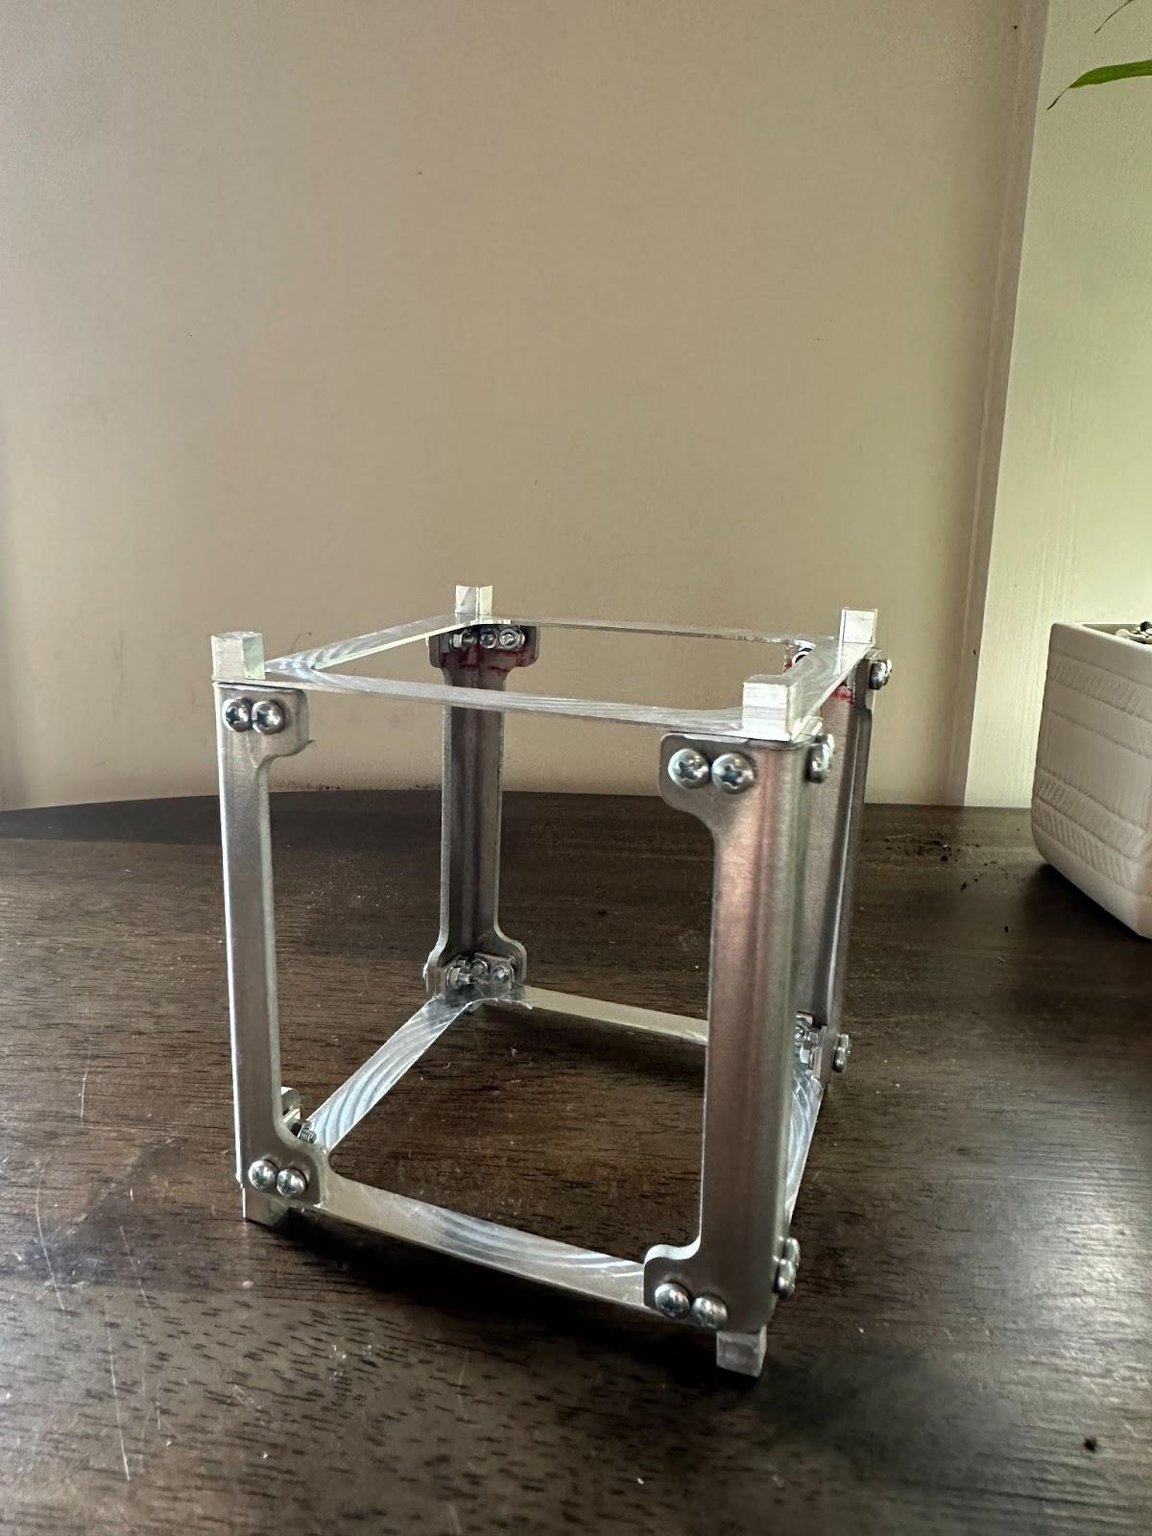

**Figure 19: CubeSat Chassis**

# **High Potential Accelerator Modeling Subsystem Report**

# ***Subsystem Introduction***

The High Potential Accelerator subsystem of the RIOT Drive prototype is designed to accumulate electrostatic potential and provide shielding for the CubeSat prototype. The purpose of its shielding is to increase power efficiency and give thrust with less needed power. The shielding also prevents the charge from causing an electrical arc. This is tested by constructing the accelerator plate with three insulating materials and three geometries. From these material-geometry combinations, one will be chosen and mounted onto the CubeSat prototype based on results and data collection.

# ***Subsystem Details***

For each material-geometry prototype, we made sure they have the following properties:

* Maintain an electrostatic potential up to 100kV.
* Dimensions where the plate would fit inside the CubeSat chassis, which are less than 100mm x 100mm in length and width.
* Four outer holes for mounting the thermionic cathodes.
* A middle hole where the ionizer passes through.

Each material-geometry prototype has multiple layers which include a dielectric layer, an insulating plastic material, and a conducting aluminum layer. The insulating plastic layer is the most focused to test the dielectric strength for each material. We used the following materials for the insulating plastic layer ( $ε_{0}$ is the relative permittivity):

* High Density Polyethylene (HDPE, $ε_{0}$ = 2.25).
* Polypropylene. ( $ε_{0}$ = 2.2)
* Polytetrafluoroethylene (PTFE, $ε_{0}$ = 2.1).

Three geometries for the material-geometry prototypes were chosen to test if they can prevent electrostatic discharge, protect the ionizer, and extend the electrostatic field duration without additional charging. The following geometries were used:

* Circular Plate
* Hemisphere
* Cone

# ***Subsystem Validation***

All nine material-geometry prototypes of the accelerator plate were designed in SolidWorks.and created under fabrication. For the hemisphere and cone, the four outer holes were drilled at an angle so the thermionic cathodes lean to one point, which is 2 cm from the opening of the middle hole, where the ionizer is insulated and passes through. The purpose is to create a gate cathode to control the direction of the cathodes without them hitting the edges of the metal pieces.

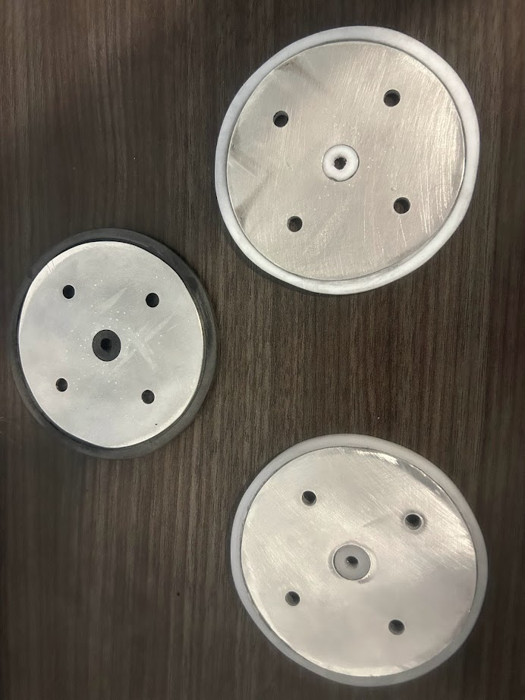

**Figure 20: Circular Plates (*Left to Right*: Polypropylene, HDPE, PTFE)**

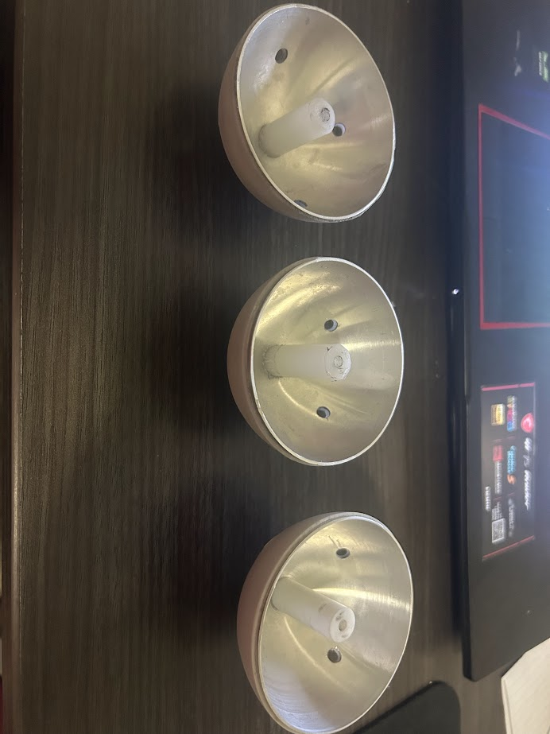

**Figure 21: Hemispheres (*Left to Right*: Polypropylene, HDPE, PTFE)**

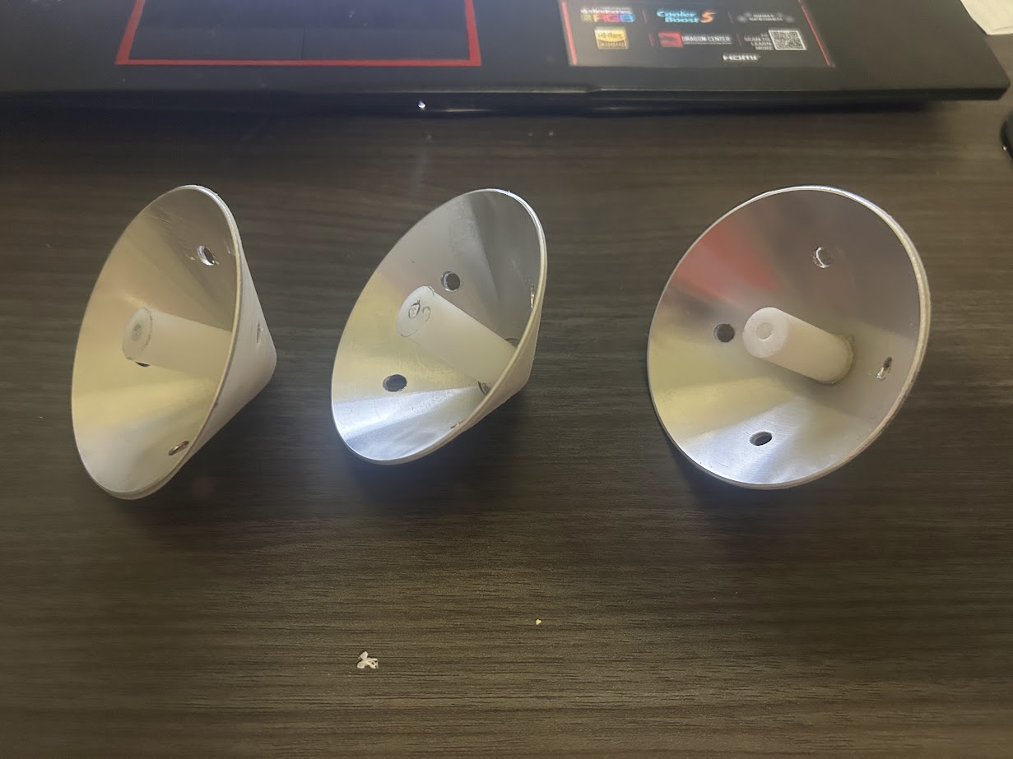

**Figure 22: Cones (*Left to Right*: Polypropylene, HDPE, PTFE)**

After all nine material-geometry prototypes were fabricated, we measured the dimensions and masses of each prototype. Using these measurements will help us choose which prototype will be used for mounting. Below is a table of the recorded measurements:

|  | Metal Diameter | Plastic Diameter | Metal Height | Plastic Height | Metal Thickness | Plastic  Thickness | Mass |
| --- | --- | --- | --- | --- | --- | --- | --- |
| HDPE Circular Plate | 82 mm | 90 mm | 1 mm | 3 mm | 1 mm | 1 mm | 27 g |
| HDPE Hemisphere | 76 mm | 78 mm | 38 mm | 39 mm | 1 mm | 1 mm | 34 g |
| HDPE Cone | 76 mm | 78 mm | 38 mm | 39 mm | 1 mm | 1 mm | 20 g |
| Polypropylene Circular Plate | 82 mm | 90 mm | 1 mm | 5 mm | 1 mm | 1 mm | 35 g |
| Polypropylene Hemisphere | 76 mm | 78 mm | 38 mm | 39 mm | 1 mm | 1 mm | 31 g |
| Polypropylene  Cone | 76 mm | 78 mm | 38 mm | 39 mm | 1 mm | 1 mm | 18 g |
| PTFE Circular Plate | 82 mm | 90 mm | 1 mm | 3 mm | X | X | 41 g |
| PTFE Hemisphere | 76 mm | 78 mm | 38 mm | 39 mm | 1 mm | 1 mm | 49 g |
| PTFE Cone | 76 mm | 78 mm | 38 mm | 39 mm | 1 mm | 1 mm | 32 g |

**Table 2: Measurements of Plates**

* 1. ***Subsystem Failures***

The insulating material piece for the hemisphere and cone geometries is expected to have a thickness of at least 2 mm, but there was a slight error in fabrication as these have a thickness of 1 mm. Also, the aluminum piece for the hemisphere doesn’t fit all the way where it can be covered entirely by the insulating material. In 404, we will still record their electrostatic potentials, but if the plastic pieces can’t handle the voltage due to them being too thin, we may consider re-fabricating them.

* 1. ***Subsystem Conclusion***

All nine material-geometry plate prototypes were completed and ensured that they followed the specifications to fit inside the CubeSat chassis and thermionic cathode mounting. In 404, we will measure the electrostatic potential for each plate and will use the best-working plate for mounting based on our results and data collection.